**CS 7700 Advanced Database Systems Programming Project**

**Summer 2020**

(Nikhil Chavan, U00969241, chavan.10@wright.edu)

**Project Idea:** Hotel Reservation System

**Programming Languages:** Java, MySQL

**Tools:** Eclipse, Access Database

**Entity Relationship Diagram(ERD):**

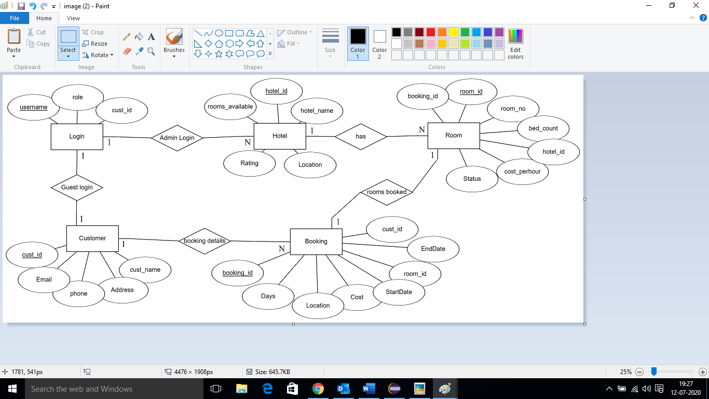

**Assumptions for Relationships between the Tables:**

* **Login to Hotel (1 to N) :** Since a valid Admin user could add/update/delete many hotels/rooms at any location of his choice based on the valid hotel id or room id entered by the user for updating and deleting operations. However, while Adding a new hotel or room a new record will be created either in Hotel or Room according to the user specifics.
* **Login to Customer (1 to 1):** A valid guest user could have only one customer details, and the same is retrieved while booking the hotel. If the user details are not present, then the user personal details are asked while booking the Hotel room.
* **Customer to Booking (1 to N):** A customer could book as many as available rooms at different hotels at different locations.
* **Hotel to Room (1 to N):** A Single hotel at specific location could have different number of rooms which are either in available or not available status, hence one to many relationships between the tables.
* **Room to Booking (1 to 1):** A Single hotel room can be booked once at a time by the guest user at a specific hotel and location. Therefore, one to one relationship between the tables.

**Relational Schema:**

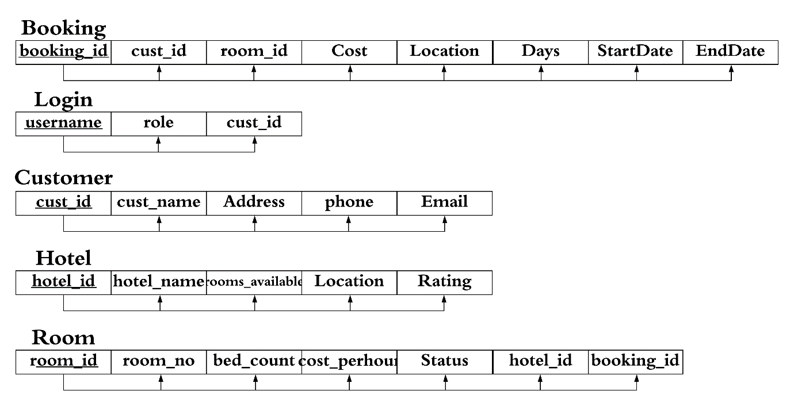

**Database tables:** Login, Hotel, Room, Booking and Customer.

**Table Schema:**

* **Login:** username, role, cust_id.
* **Hotel:** hotel_id, hotel_name, rooms_available, location, rating.
* **Room:** room_id, room_no, bed_count, cost_perhour, Status, hotel_id, booking_id.
* **Booking:** booking_id, cust_id, room_id, cost, location, days, startdate, enddate.
* **Customer:** cust_id, booking_id, cust_name, address, phone, email.

Below screenshots are the schema for the tables used in the project development.

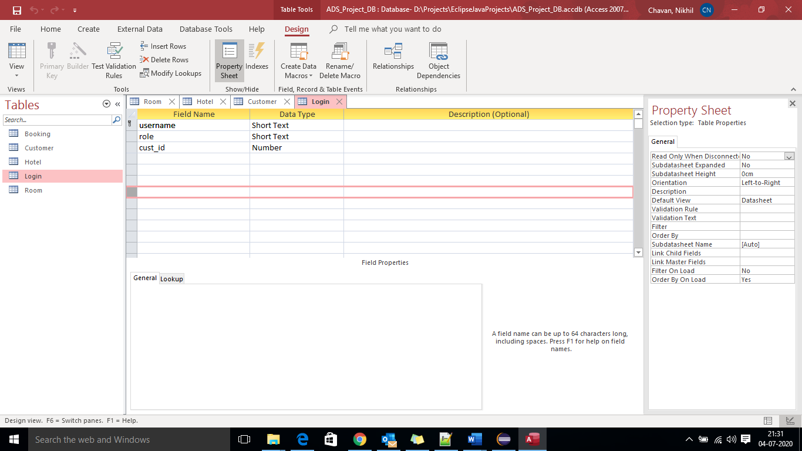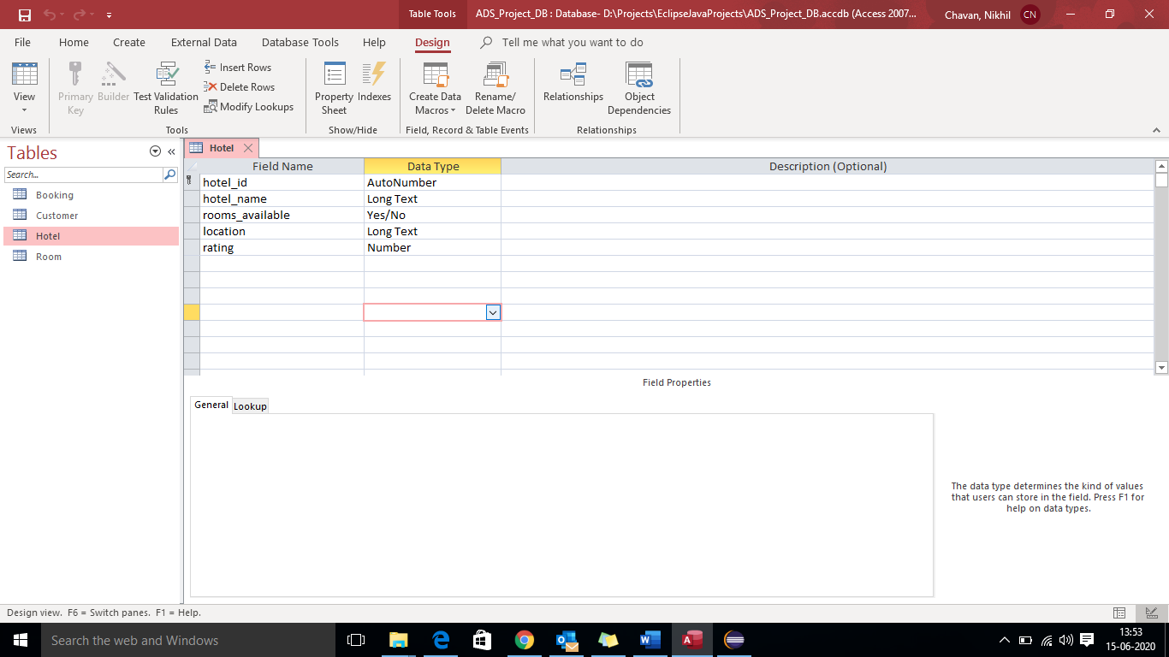 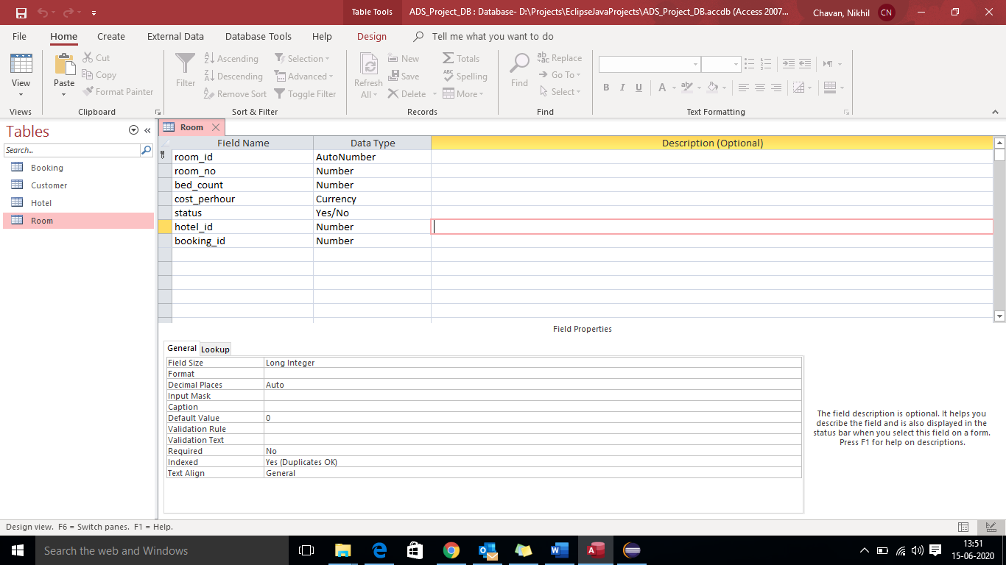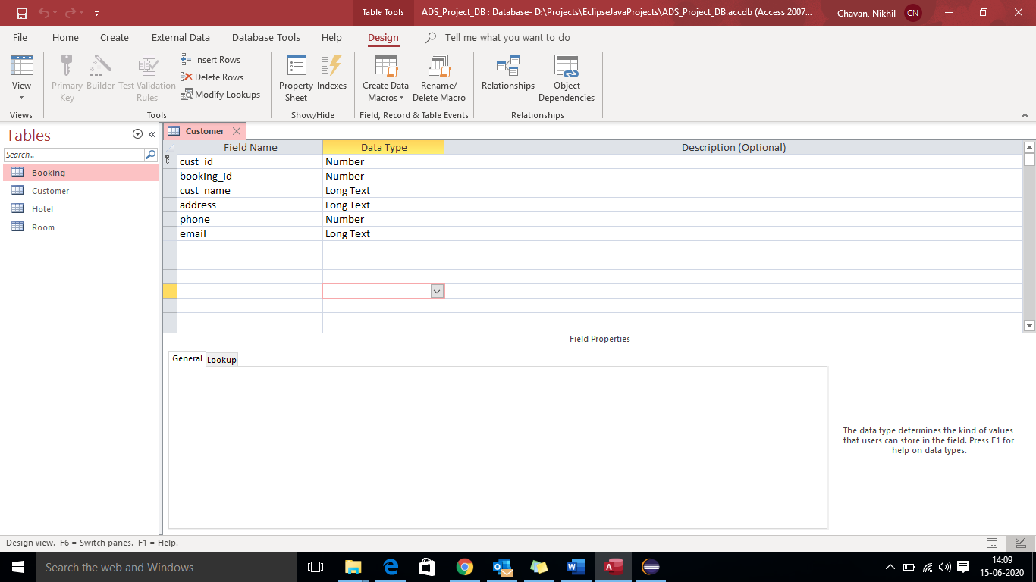 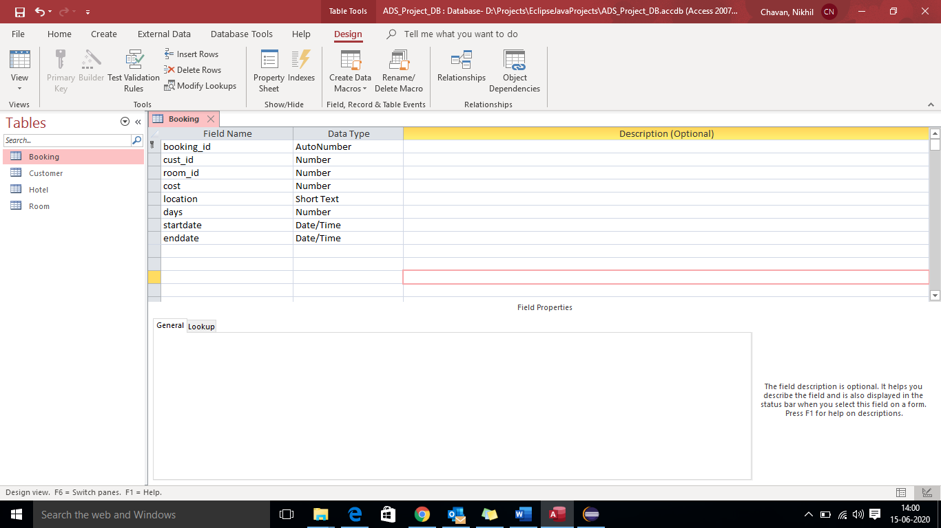

**Contents in the Tables: (**Table names are highlighted in **RED** in all the below screenshots**)**

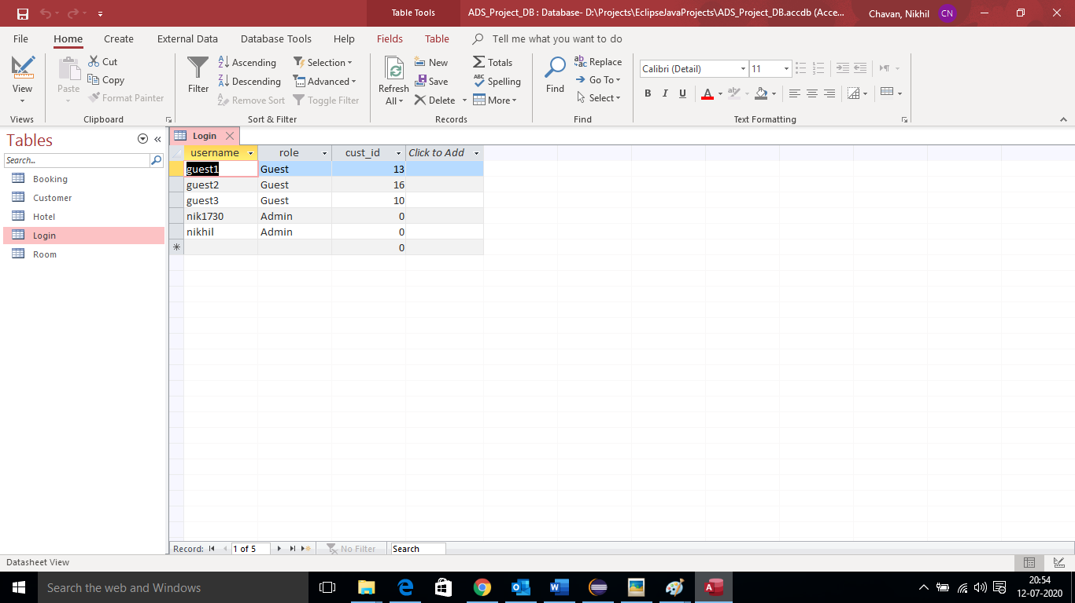 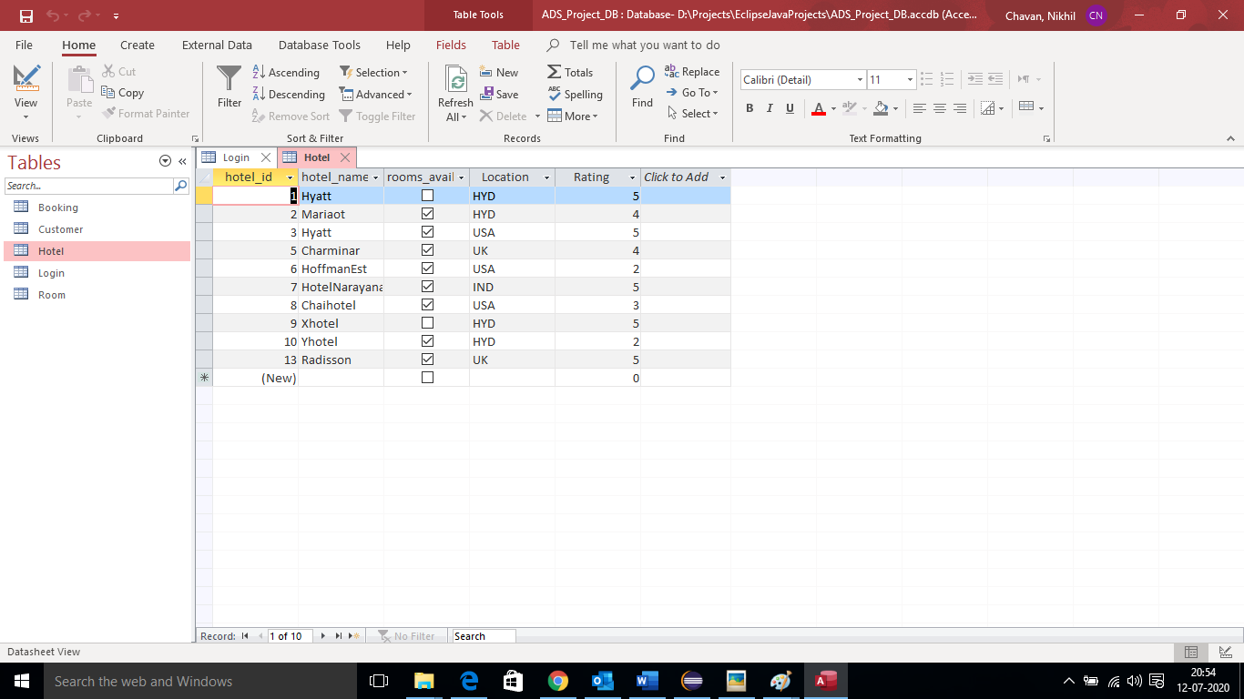 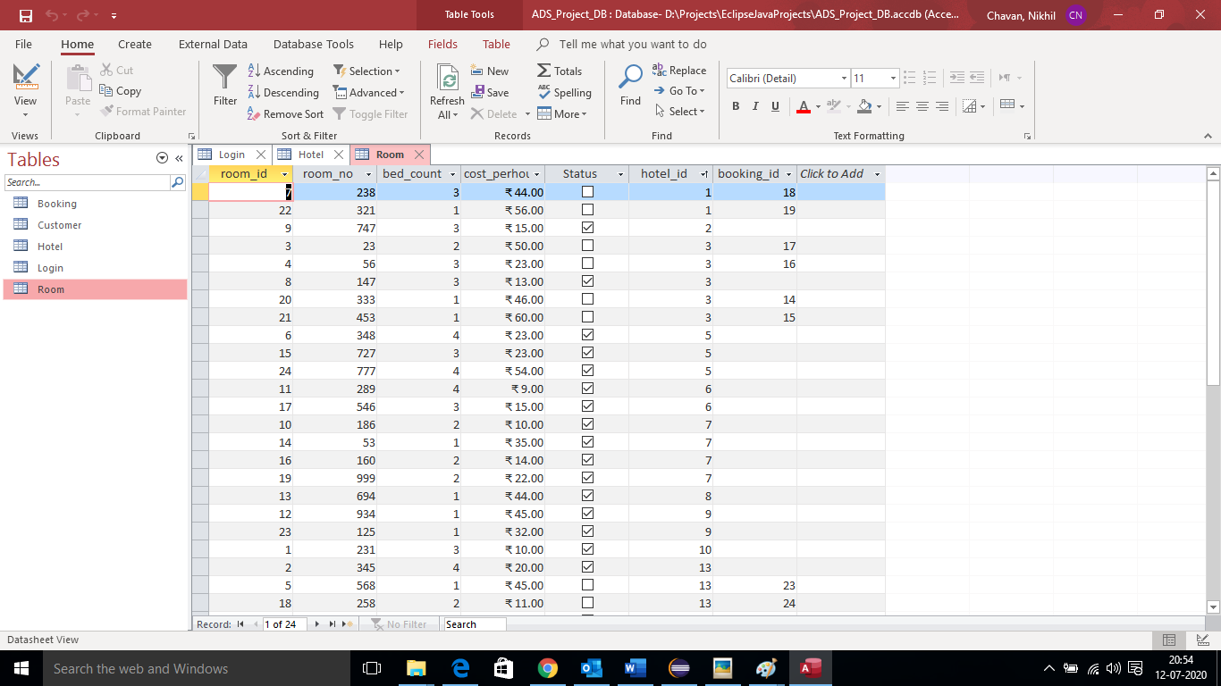 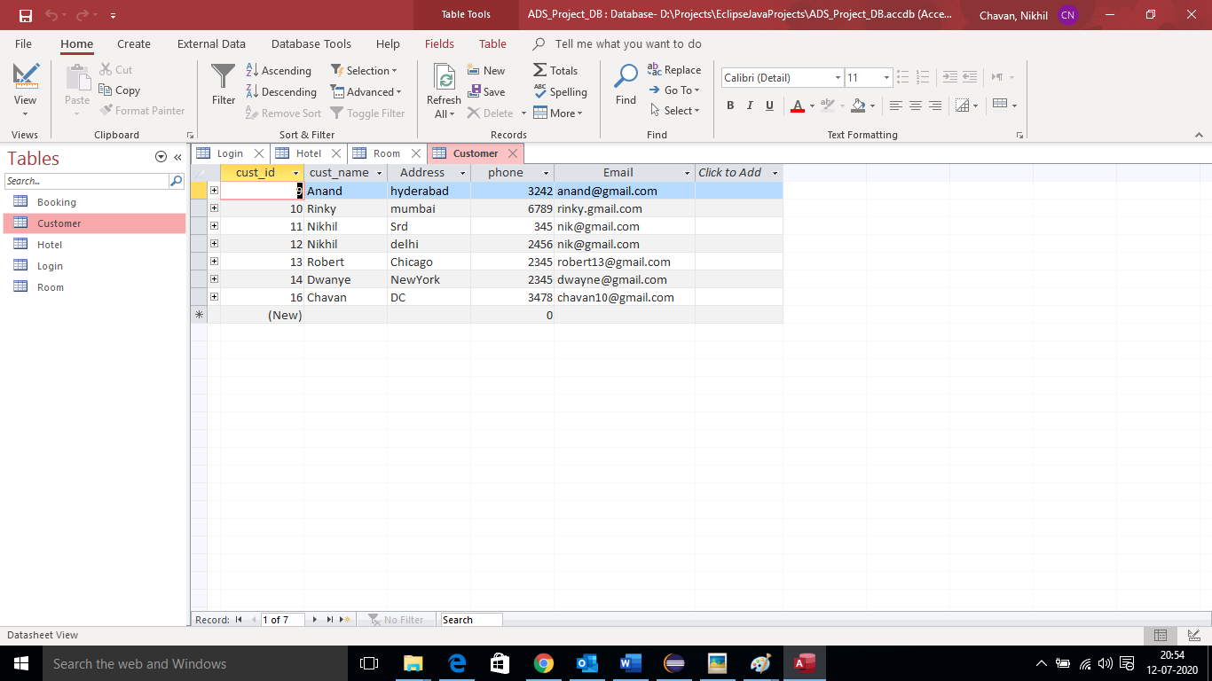 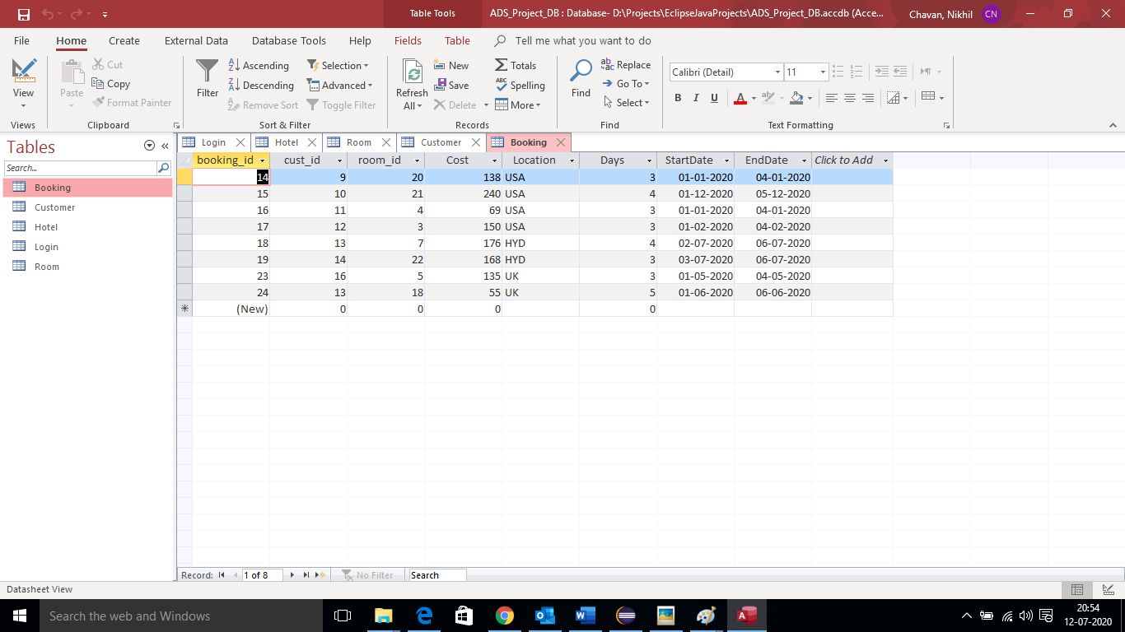

**Process Flow of the Project**

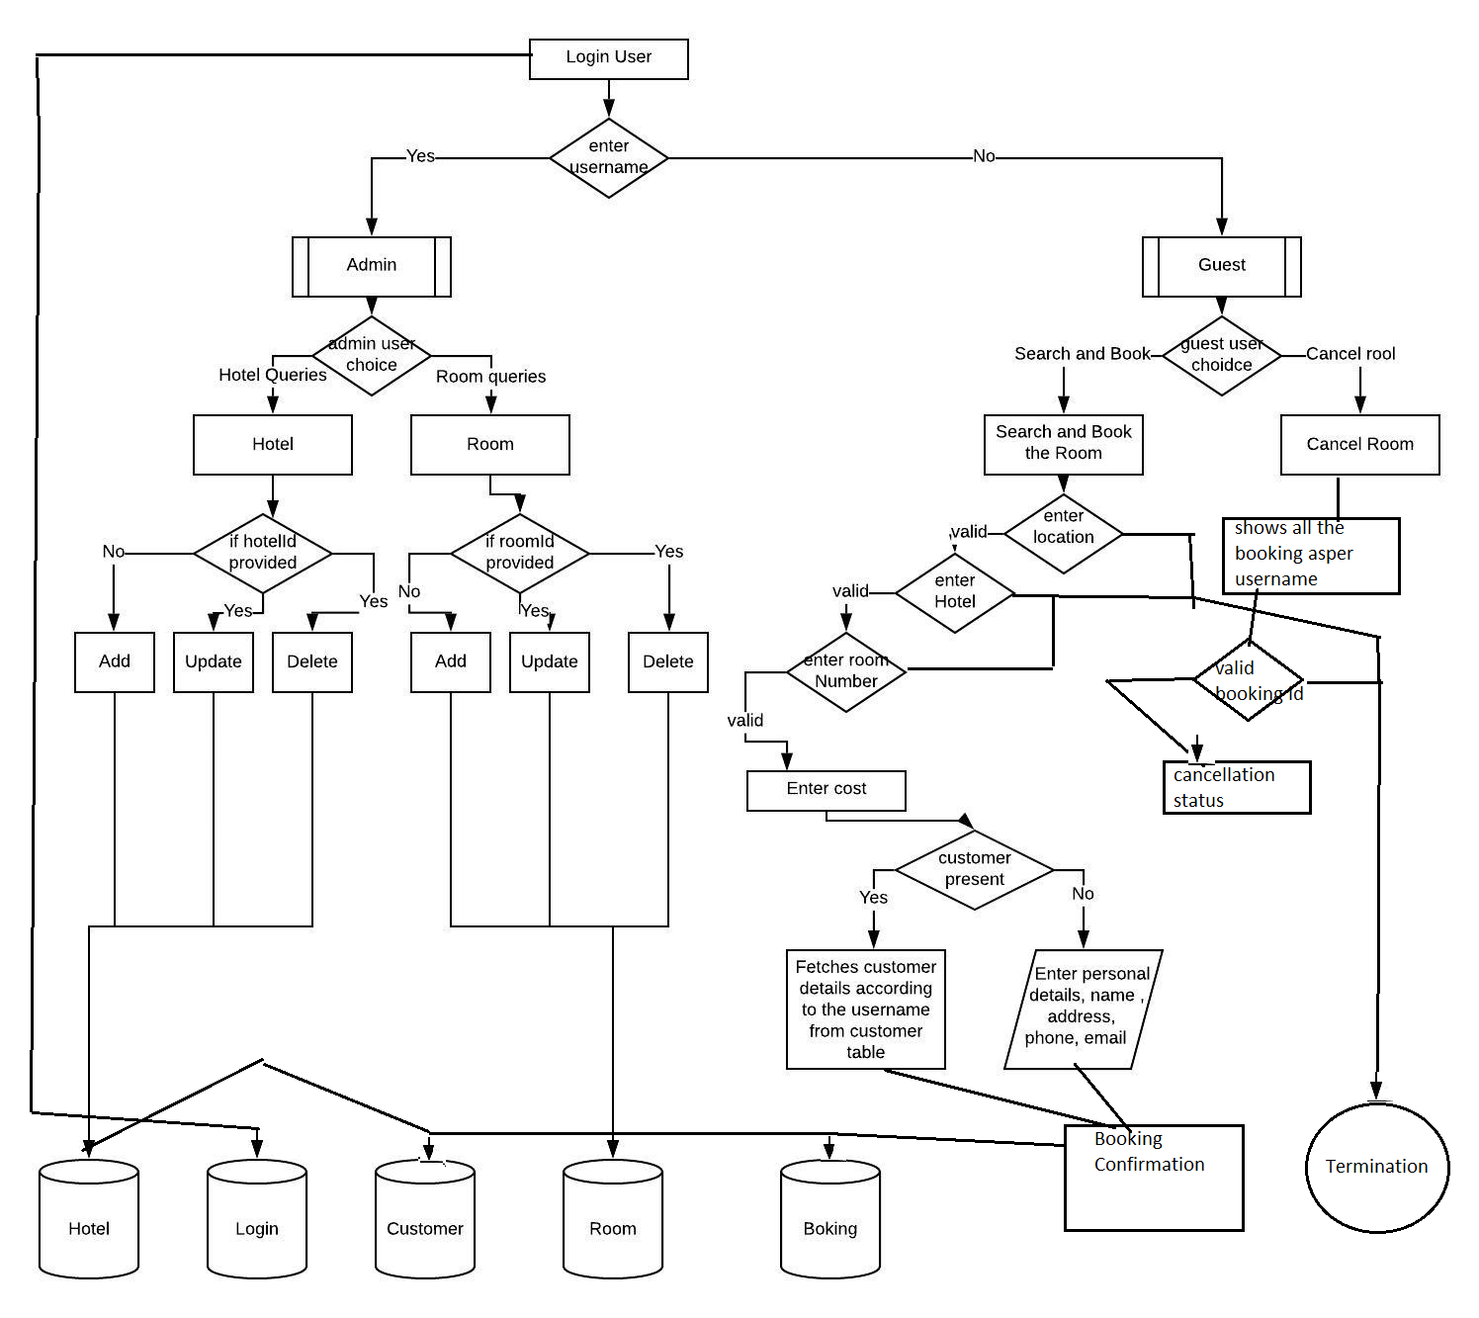

**Project Transactions Description:** The project on Booking a Hotel Room comprises of three transactions. The username of the user is needed to classify users as admin and guest.

* **Add a Hotel room specifics:** A admin user could able to make changes of the Hotel room cost, adding a new room in the hotel, changing the capacity of a hotel room, adding a new hotel in the location and all Hotel and Room management changes,
* **Search and Book a Hotel Room:** A guest user could able to search for available hotel rooms by hotel location, hotel rating, number of beds in the selected hotel room, selected hotel room cost. Upon selecting the room, in order to book the hotel room, a user must enter his personal information, start date and end date then system outputs with the booking confirmation along with the booking information.
* **Cancelling a Room:** The guest user could able to cancel the booked room by providing the booking information as an input and system outputs the cancellation confirmation.

The project starts with the providing of the username, here the assumption is users are all signed up to the application. For the admin user, the system shows different options like make changes of the Hotel room cost, adding a new room in the hotel, changing the capacity of a hotel room, adding a new hotel in the location, thus alternatively corresponding database transactions are carried on the tables i.e. Hotel and Room tables.

To perform, search and book a hotel room, a Guest User can search for a hotel at a location, once the available hotels at the locations are displayed, the user is asked to select the hotel to book. Later, from the database, the available rooms are shown to the user along with its room number, bed count, and cost per day. The user must select the room and must provide the number of days of stay. The final cost according to the number of days is calculated which differs according to the location, hotel, number of days to stay, and cost. The user must confirm the booking, by selecting Yes or No option. Then the system would ask for the personal details of the customer like Name, Address, Phone number and Email address furthermore the user must provide the Start date and End date in dd/MM/YYYY, once the dates are inputted, the system performs the validation to check the formatting of the input data, then checks if the end date is greater than the start date, later number of days of stay and days between the start date and end date are validated if everything is perfect finally, the booking details are shown to the user i.e. the booking id along with the customer details, start date, end date, and the final cost and then accordingly the database tables are also updated i.e. insert or delete of data from the database tables referred below.

For cancelling a confirmed Hotel room, the user has to provide the booking id from the booking confirmation information, then the database checks for the booking id and does the necessary database changes in all the tables i.e. changing the room status to available, deleting the customer personal details, updating the booking table and accordingly making the hotels available at a location according to the status of the room in the hotel.

**Transactions:** After providing username the system validates and returns if the user is an admin or a guest user and correspondingly respective options are shown to the user.

**User Inputs: Enters the username**

* **Hotel and Room updates:** Enter option to select whether to change the room cost, add a new room in a hotel or add a new hotel at a location. Enter hotel id, room id and new cost, enter room number, bed count, cost to add a new room, enter a new hotel name and location in order to add a new Hotel at a specified location.
* **Search a Hotel and Book a Hotel Room:** EnterLocation, Select Hotel name, Select Room number. Select Yes/No to confirm booking, enter personal Details like Name, Address, Phone Number and Email, Enter Start date and End date.
* **Cancel a Room:** Enter booking id and customer name to cancel the room.

**System Outputs: System shows the role of the user**

* **Hotel and Room updates:** The system confirms whether a new room is added, new hotel is added, or the existing room details is updated according to the option selected by the admin user.
* **Search a Hotel and Book a Hotel Room:** Available hotels at user provided locations, Available rooms at the selected hotels with number of beds per room and cost per day stay, Total cost according to the number of days of stay provided by user, Validation or formatting errors related to the user provided start date and end date. Booking confirmation details i.e. booking id along with the customer details, start date, end date and the final cost.
* **Cancel a Room:** Cancellation confirmation details for the provided booking confirmation details.

**Screen Shots of Source Code: (**PFA the class file i.e. source code in the end of file**)**

**Source Code Attachment:**

 .java source code  .txt source code

 Entire project source code along with the database table values.

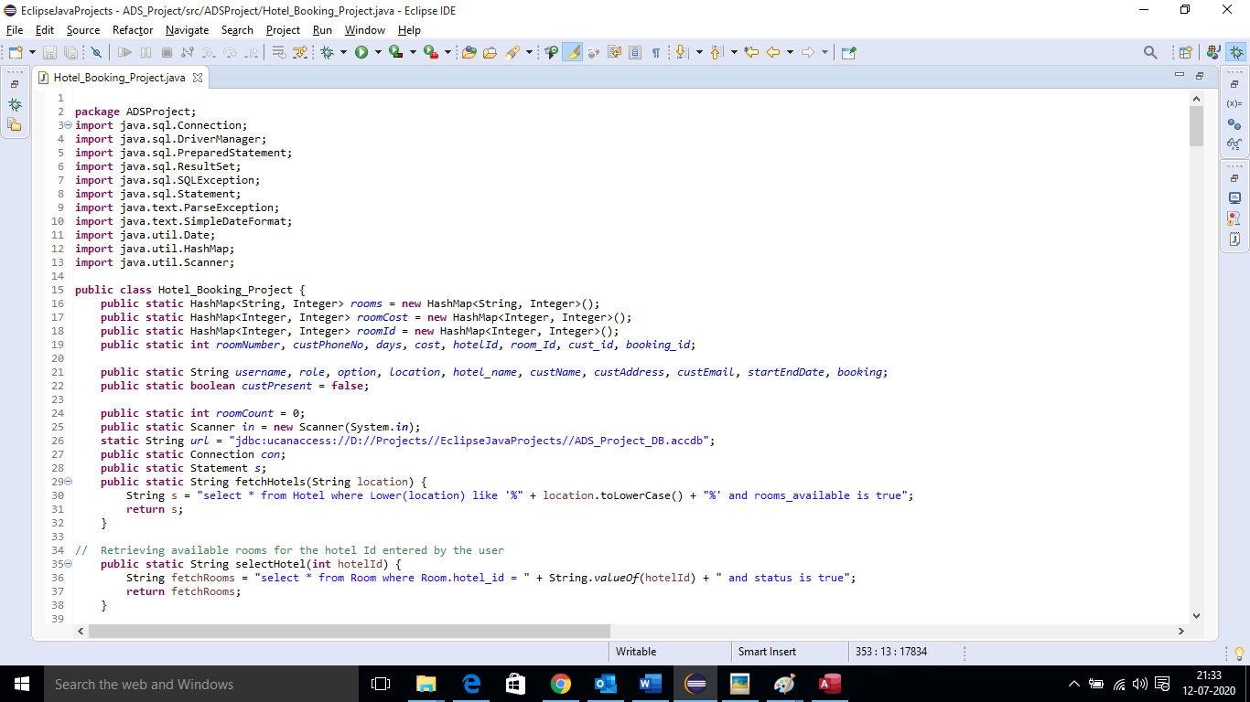 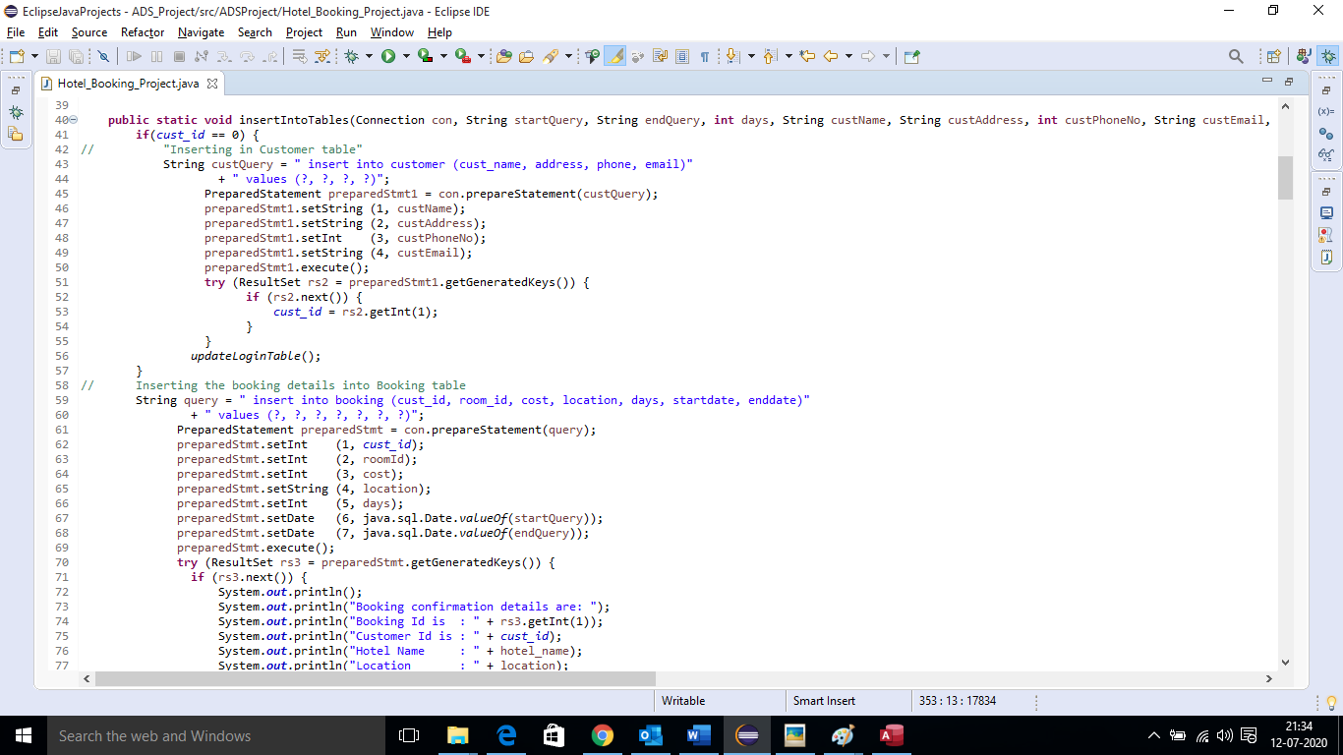

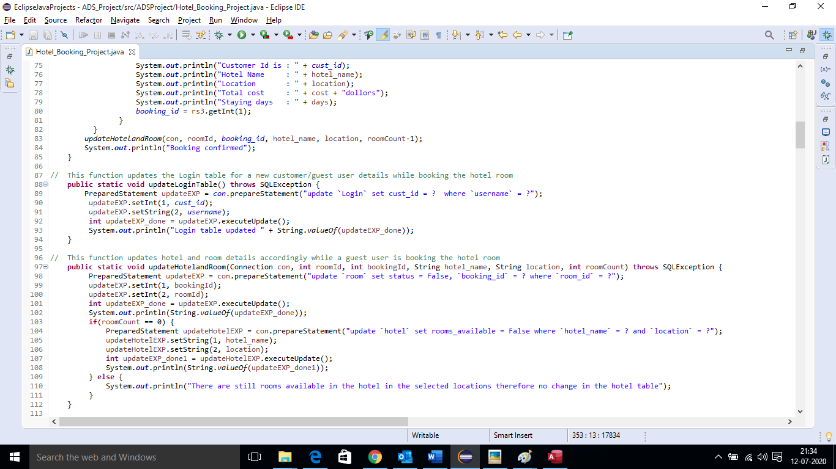

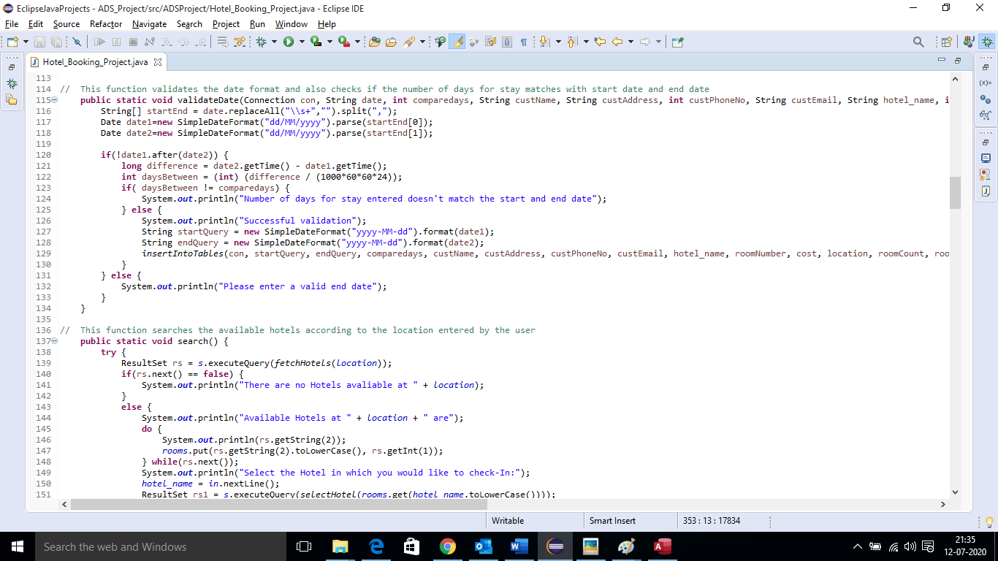 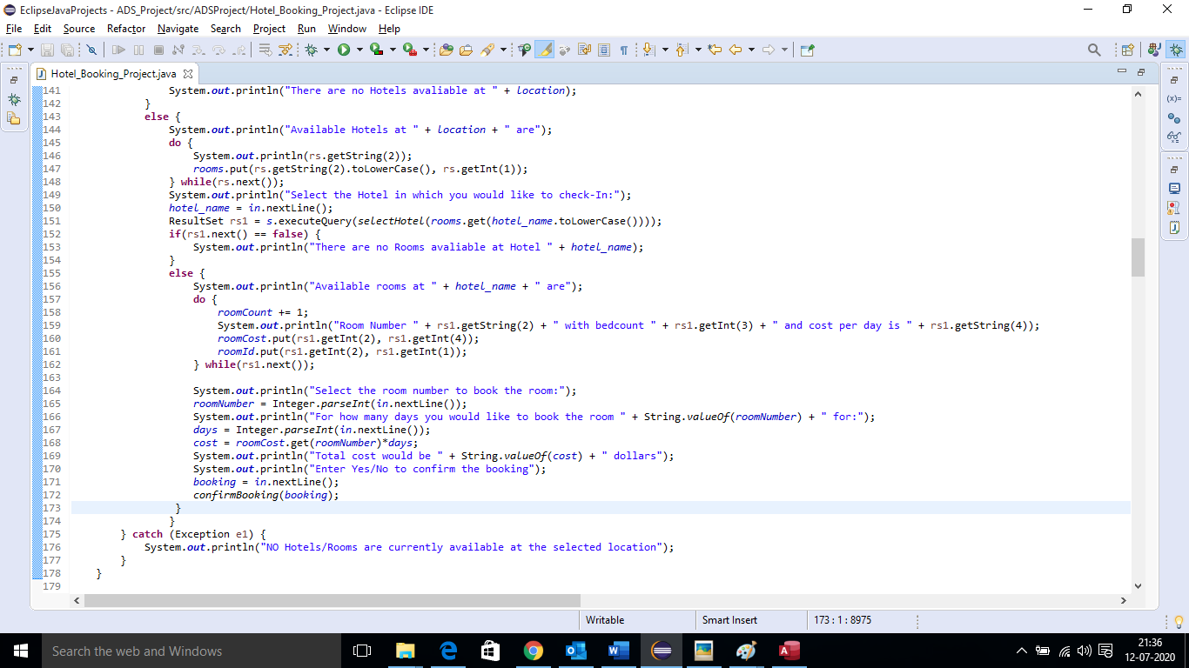 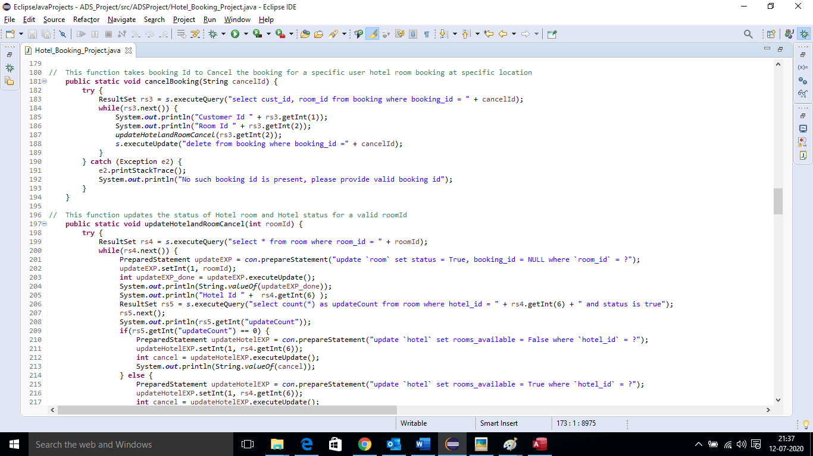 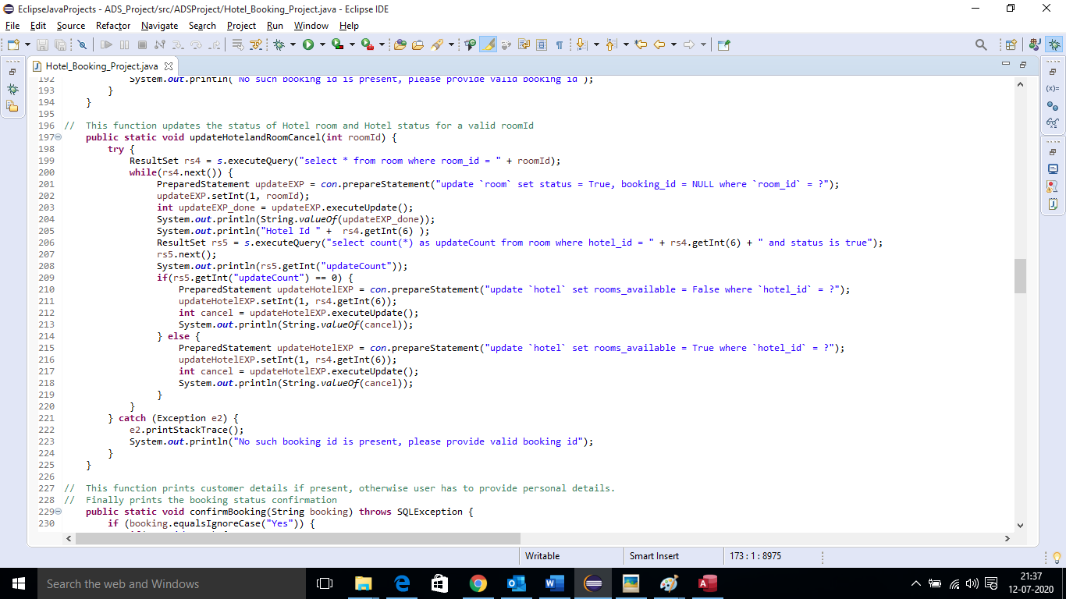

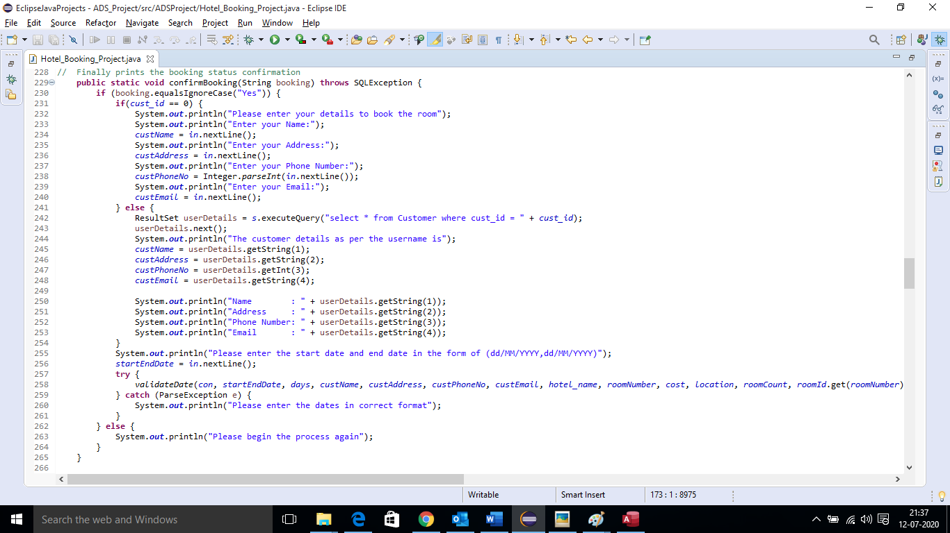

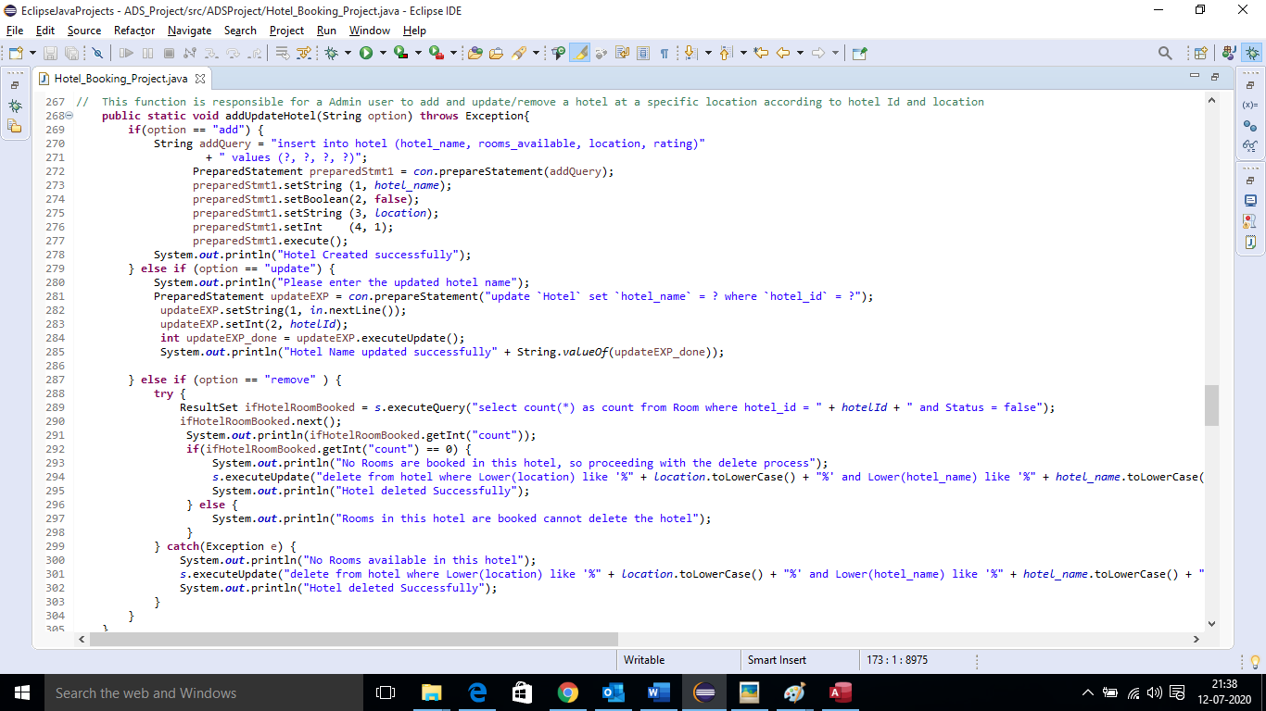 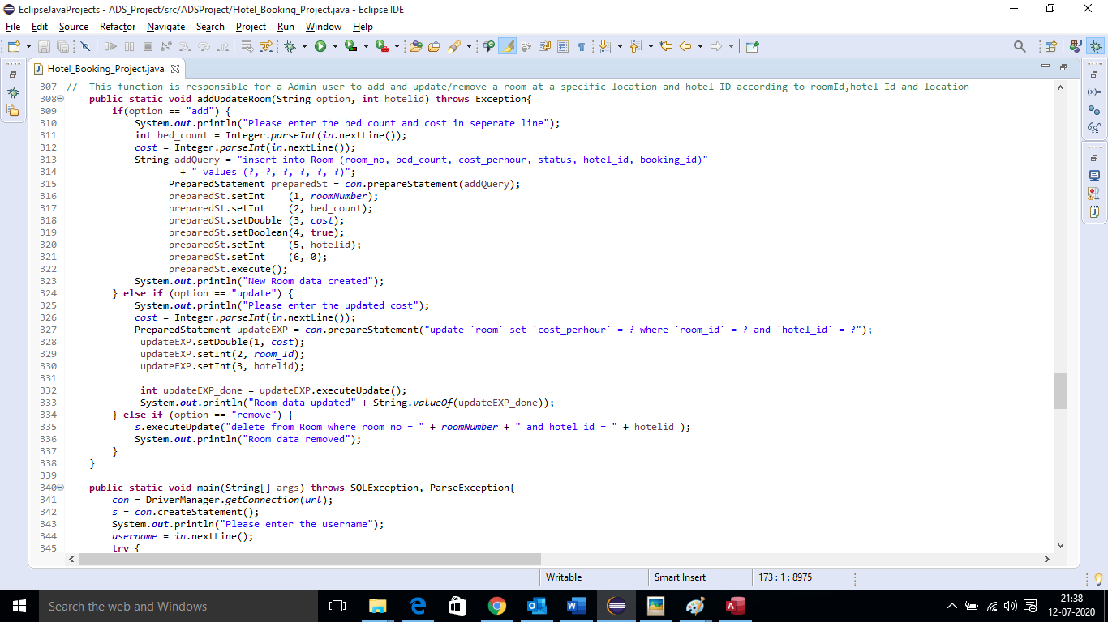 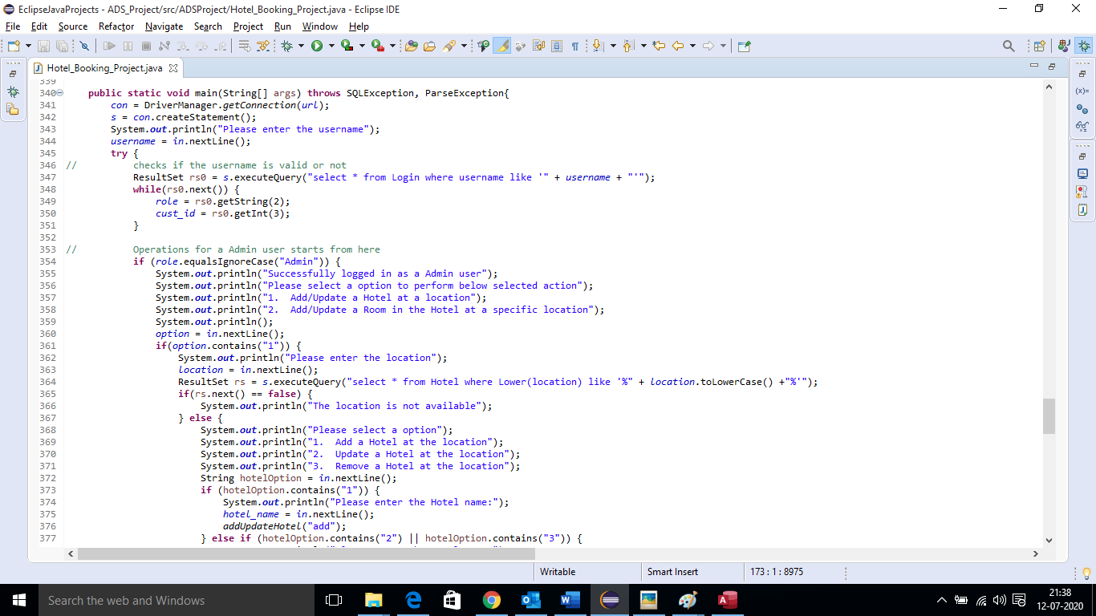 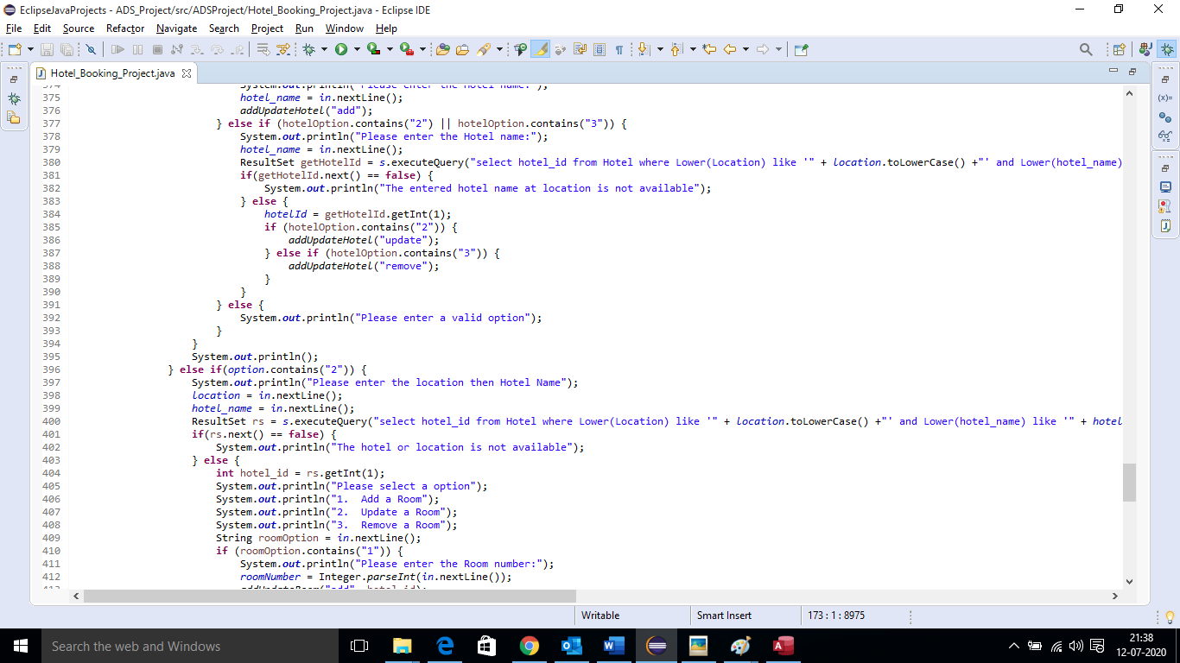 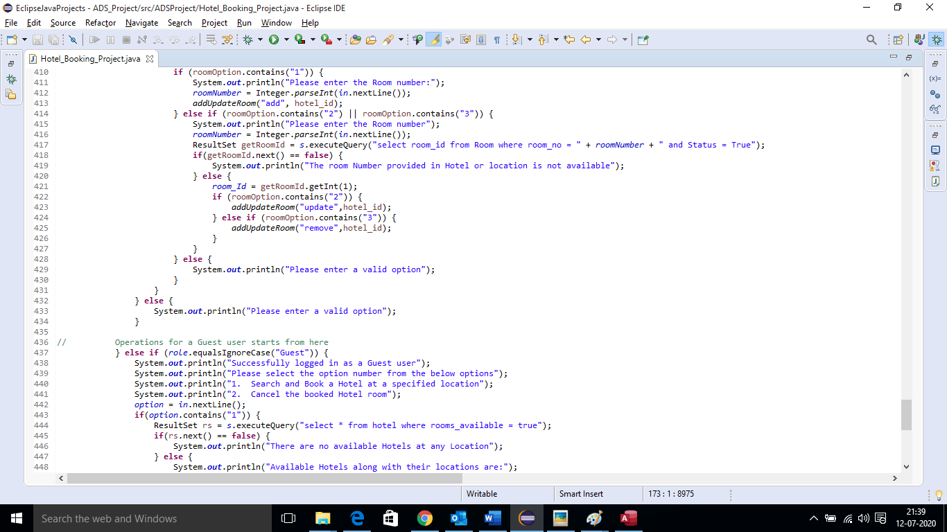 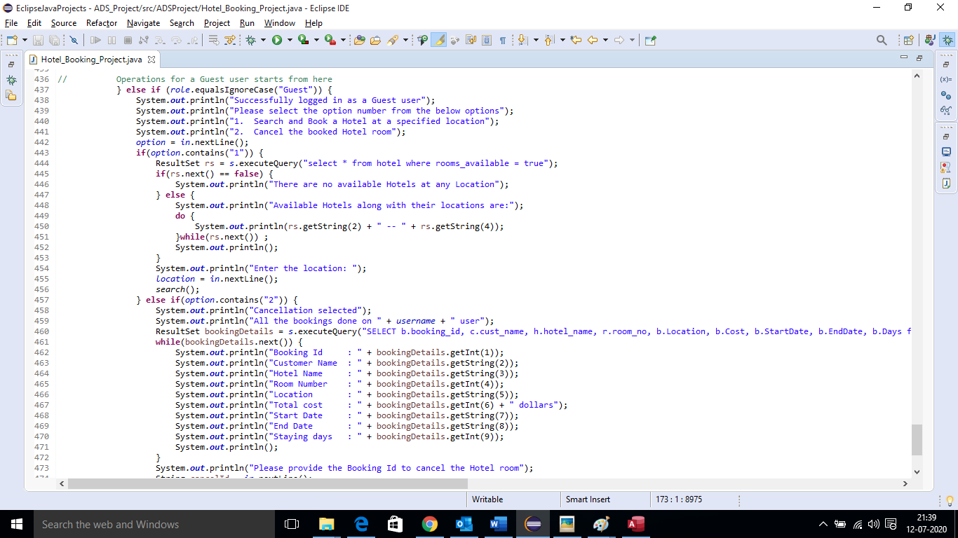

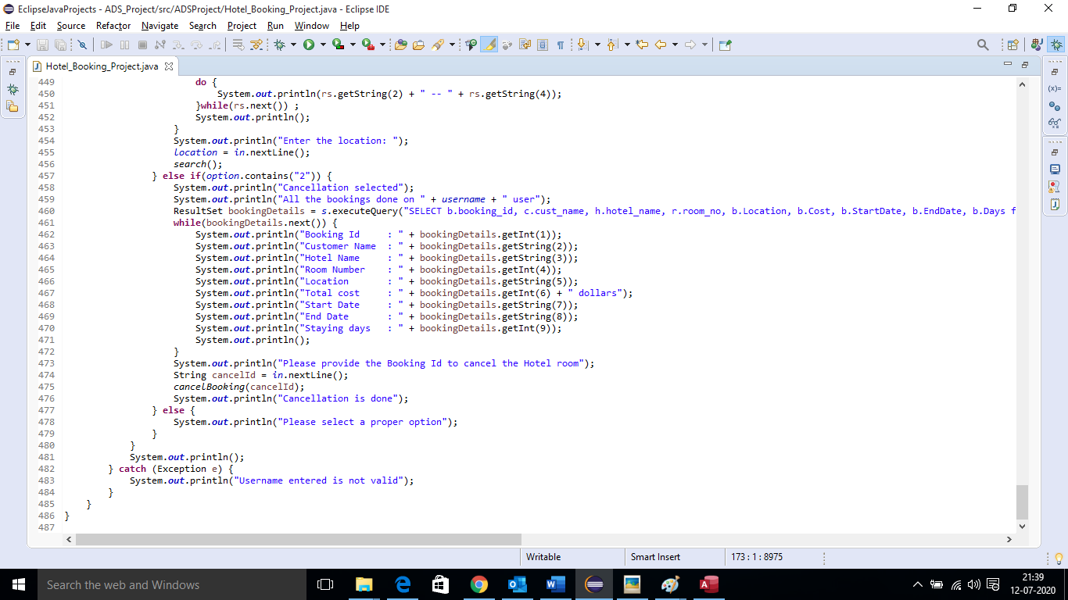

**Screen Shots of All the Transactions:**

Below screenshots shows the options available for a valid admin user “**nik1730**” and valid guest user “**guest1**”. The user must choose valid option number to further proceed with his selected option choice.

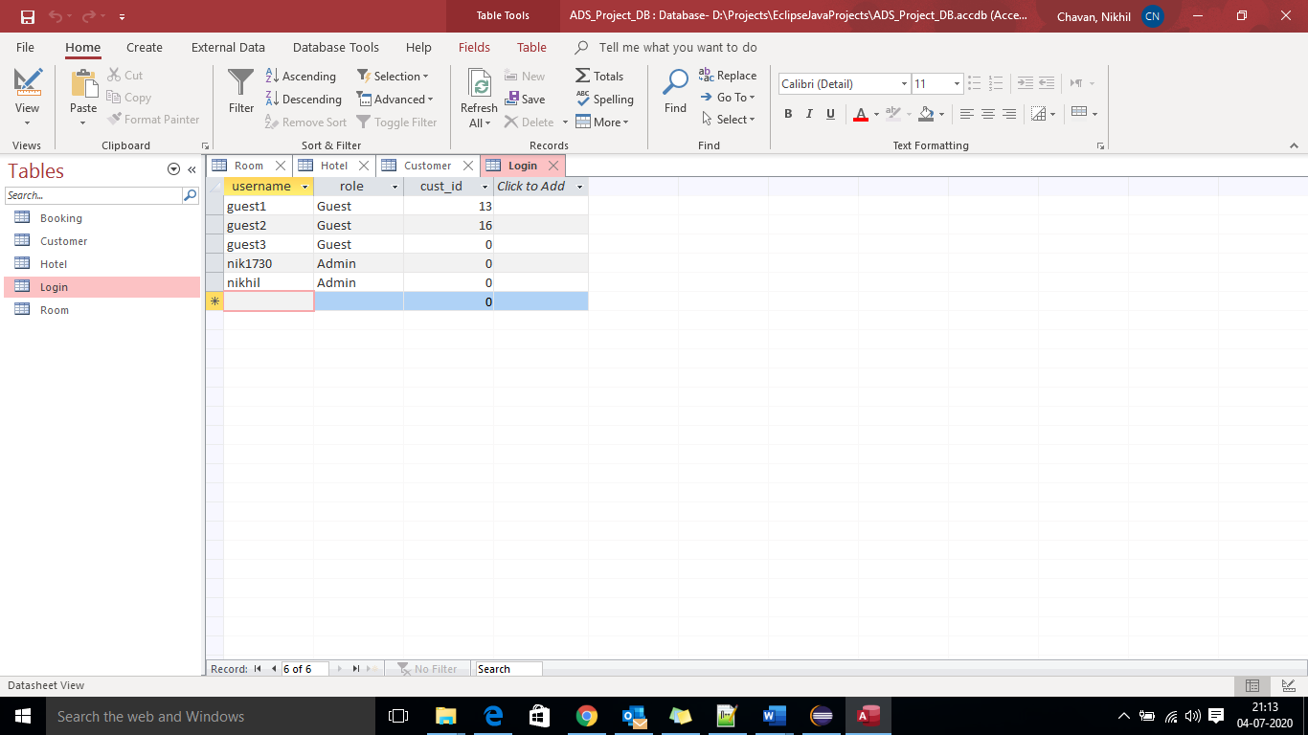

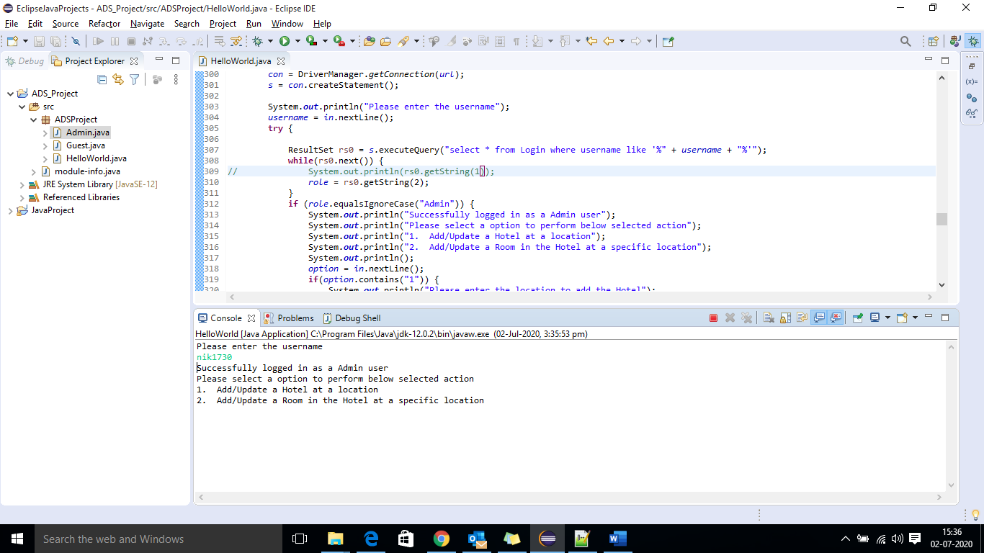

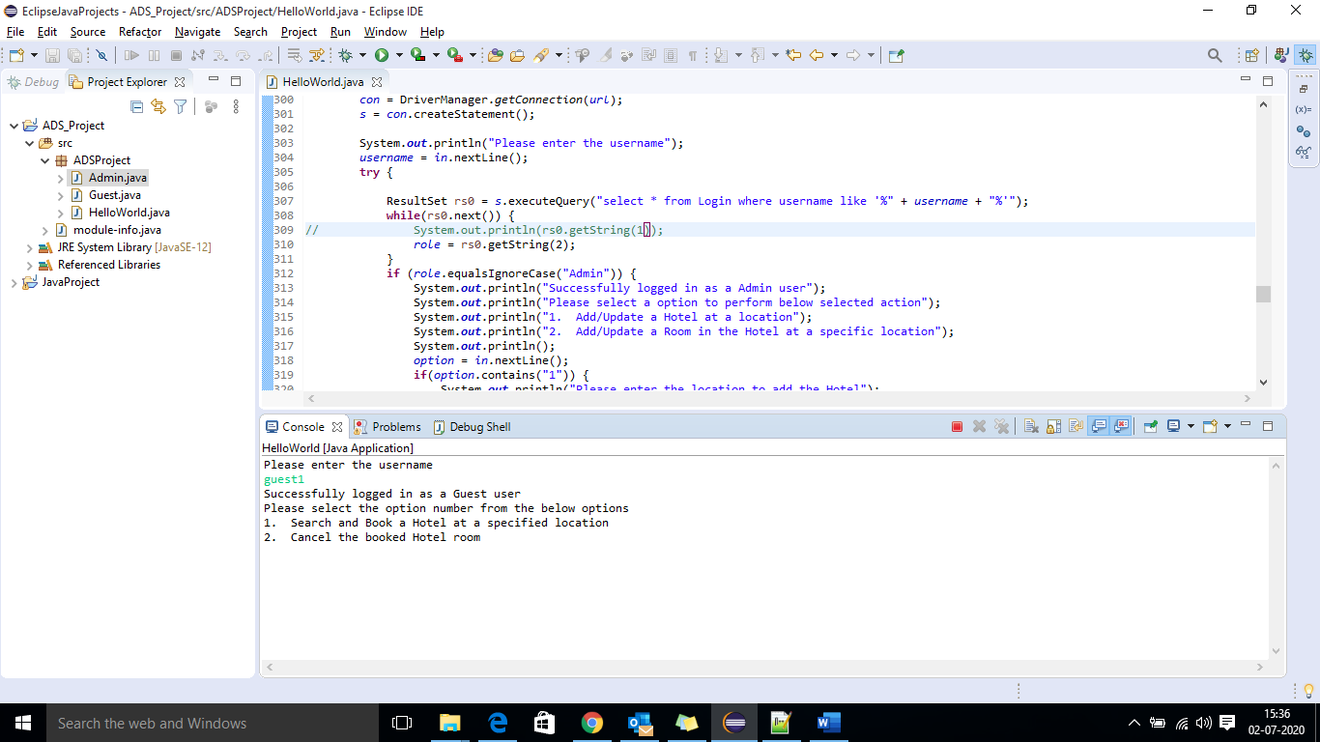

**Add a Hotel room specifics:** An admin user could able to make changes of the Hotel room cost, adding a new room in the hotel, changing the capacity of a hotel room, adding a new hotel in the location and all Hotel and Room management changes.

Below screenshot is a transaction for **Add a Hotel at “UK” with** hotel name as “Sheraton”

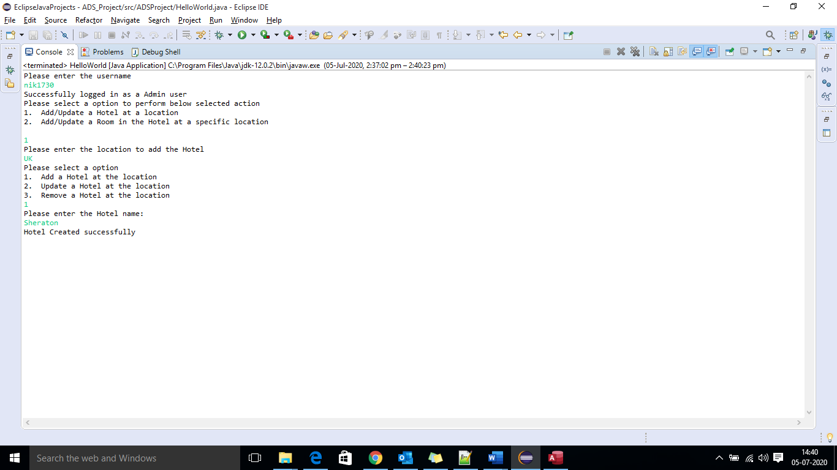

Before the Hotel is added to location UK there are only “Radisson and Charminar” in the Hotel table, below is the screenshot for the same.

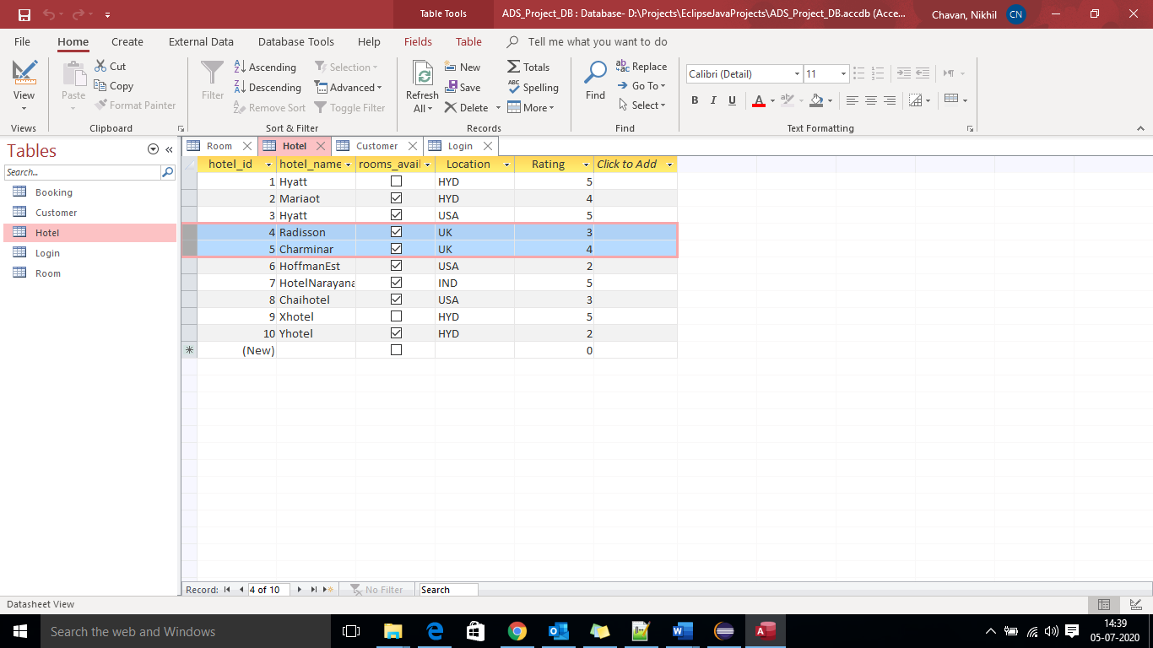

After Hotel name “Sheraton” is added, below is the screenshot of the Hotel table.

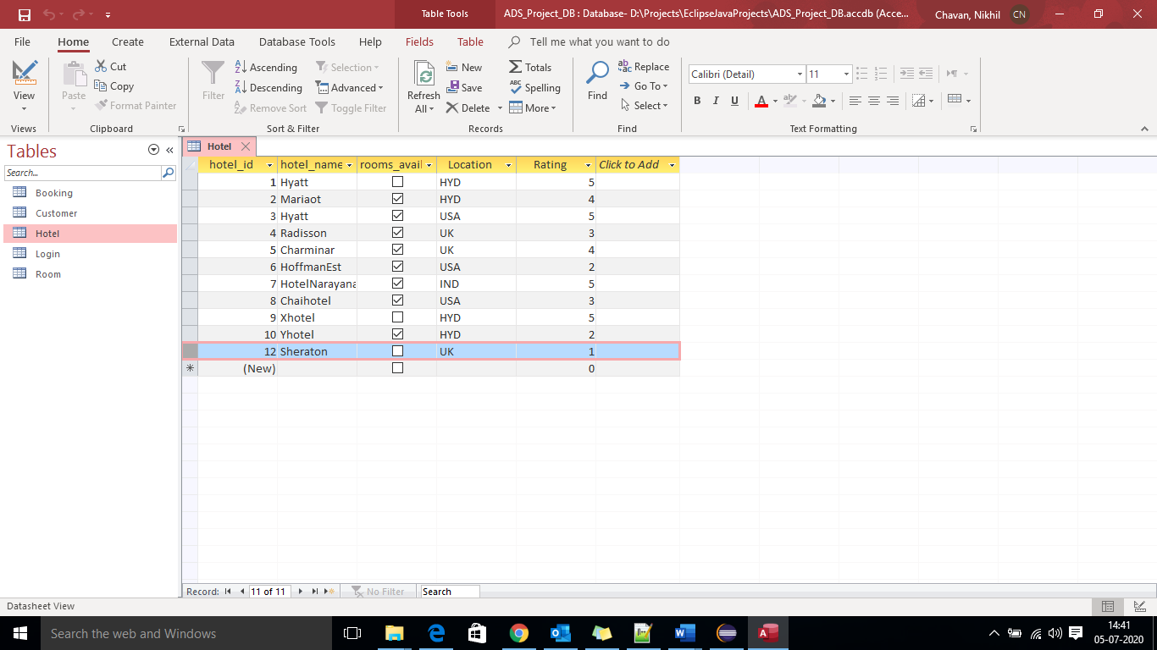

**Updating** Hotel Name **‘Sheraton’** to **‘Marriot’ (**highlighted the changed column in Hotel table**)**

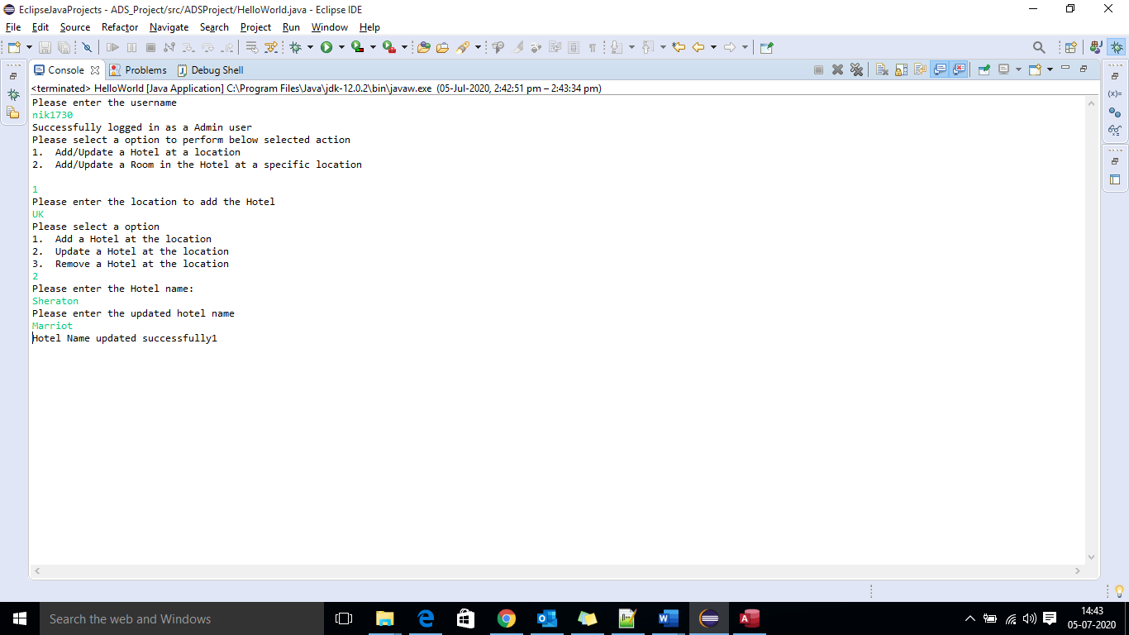

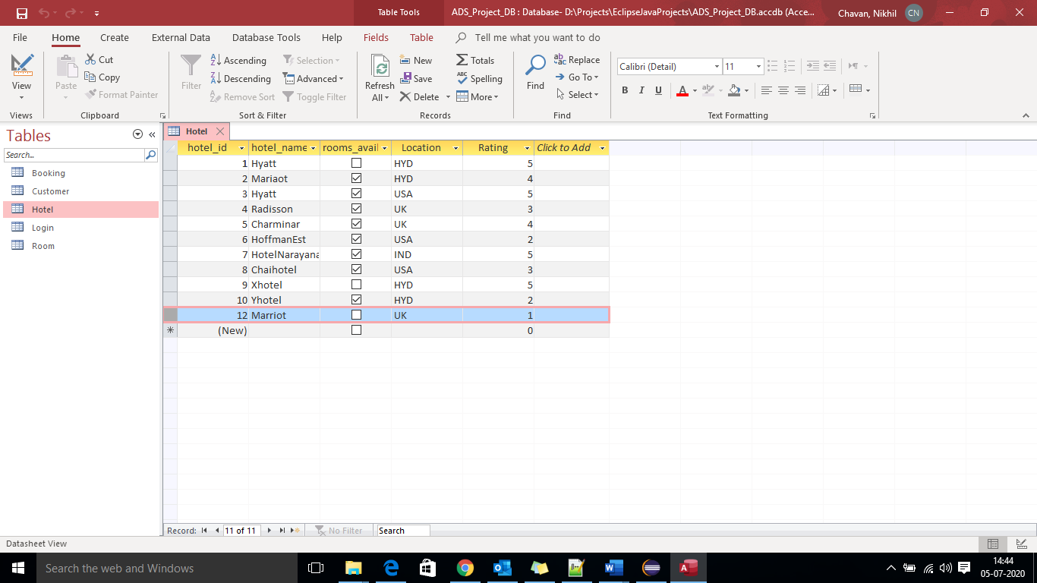An Admin user “nikhil” deleting a hotel name “Marriot” at UK location (i.e. the highlighted hotel is being deleted and the after-deletion screenshot is below)

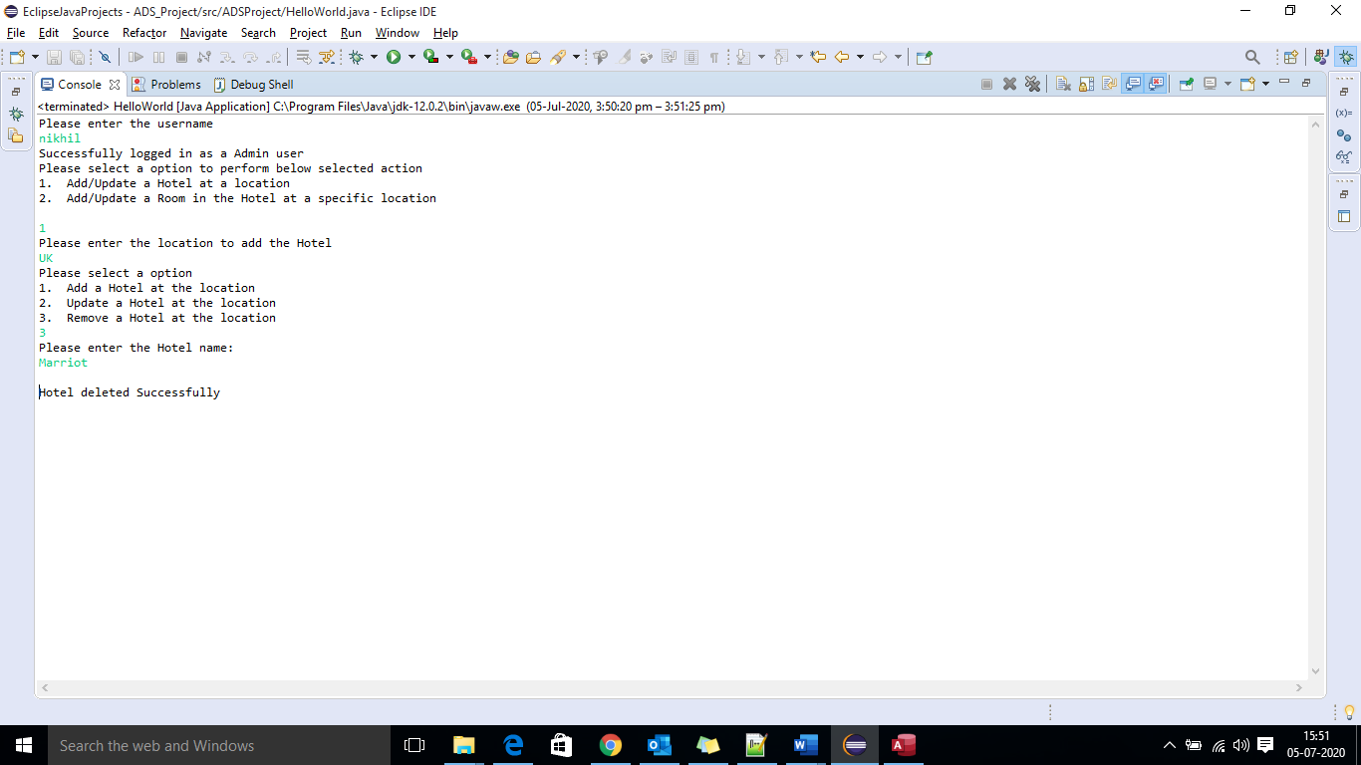

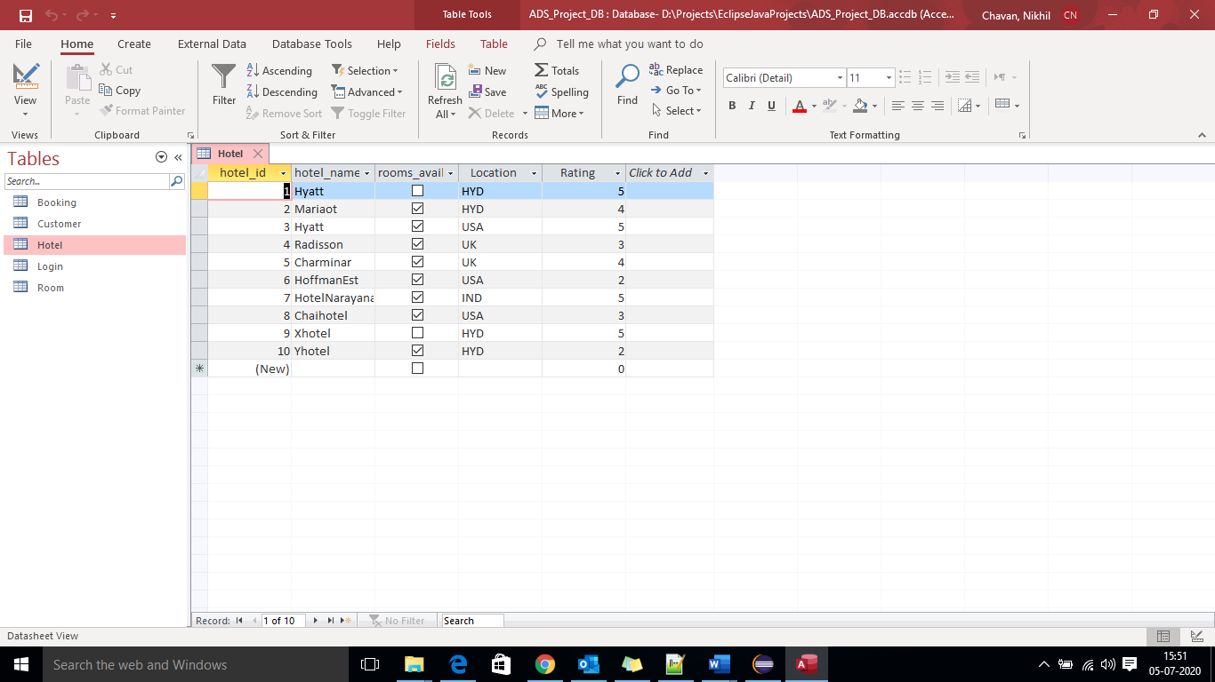

Doesn’t delete the hotel if the rooms are booked in the hotel (Checking for Radisson Hotel in UK in which the room numbers 568 and 258 are booked, highlighted rows in the below screenshot is the Room table, the other screenshot is the console error in Eclipse IDE)

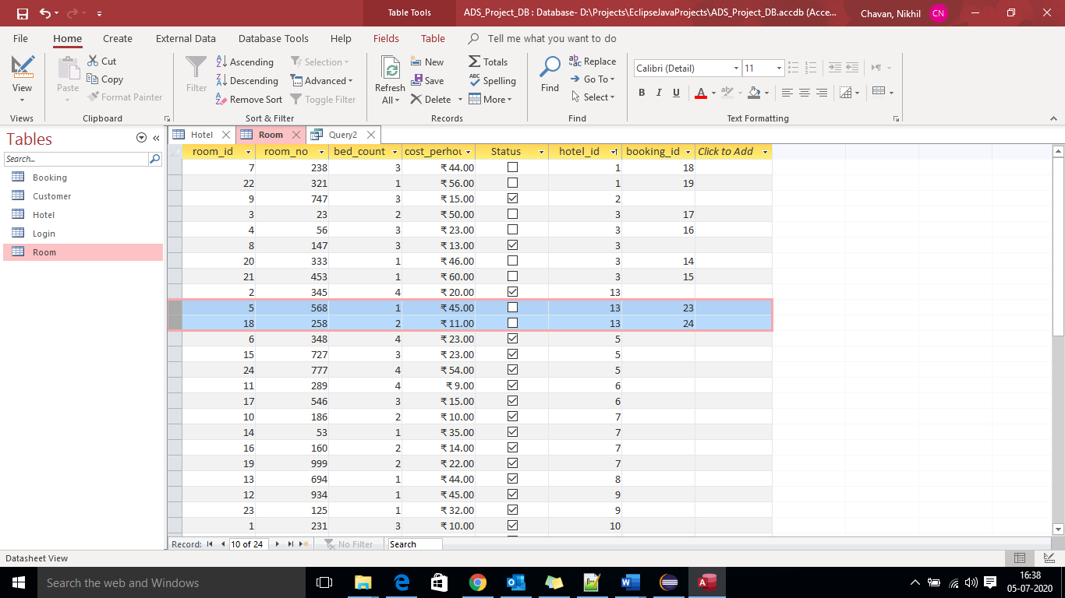

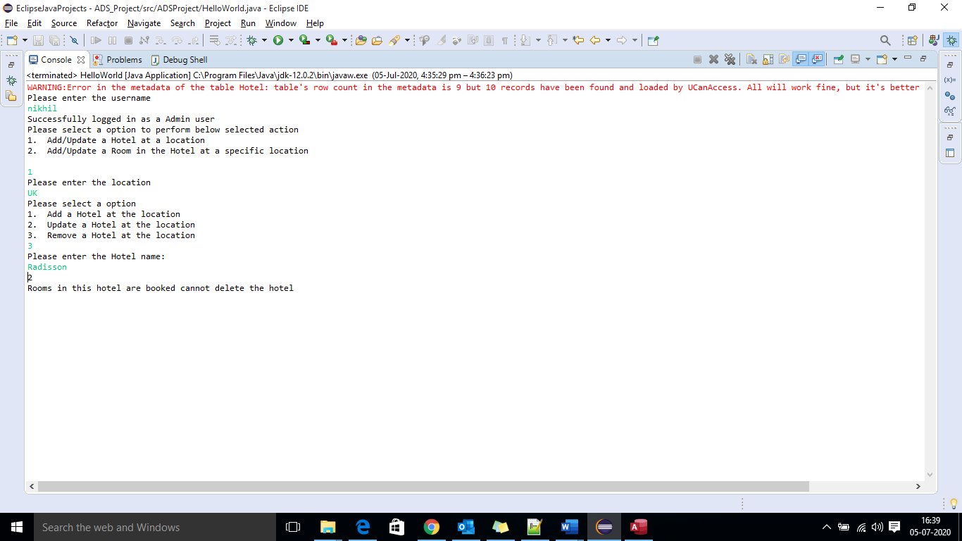

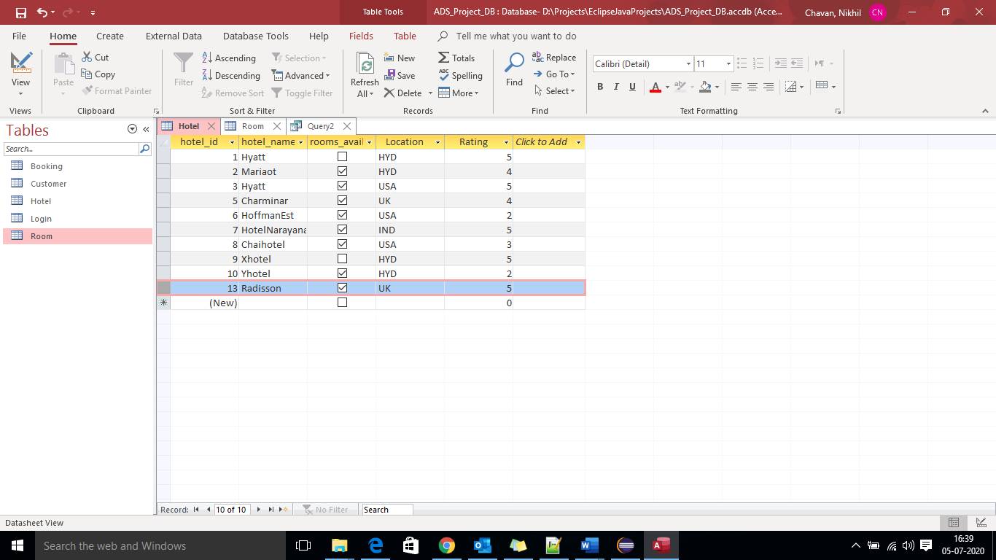

**Room Data Queries:** An Admin user adding a Room ‘666’ in Hotel Hyatt at Location USA (above Room screenshot is the before adding the room, below Room table is after addition)

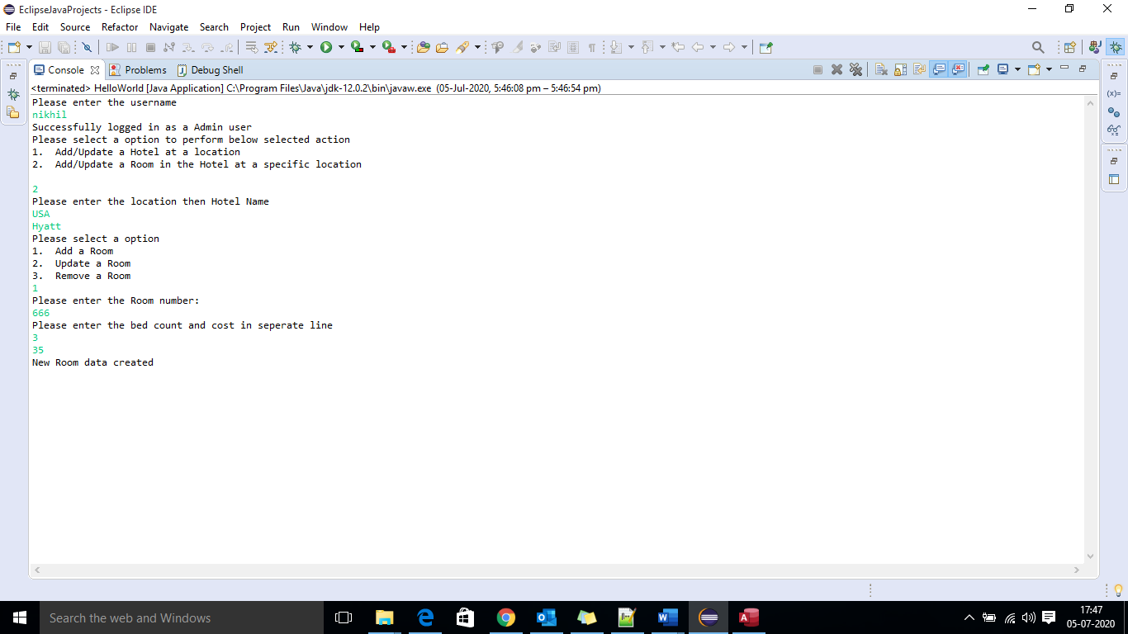

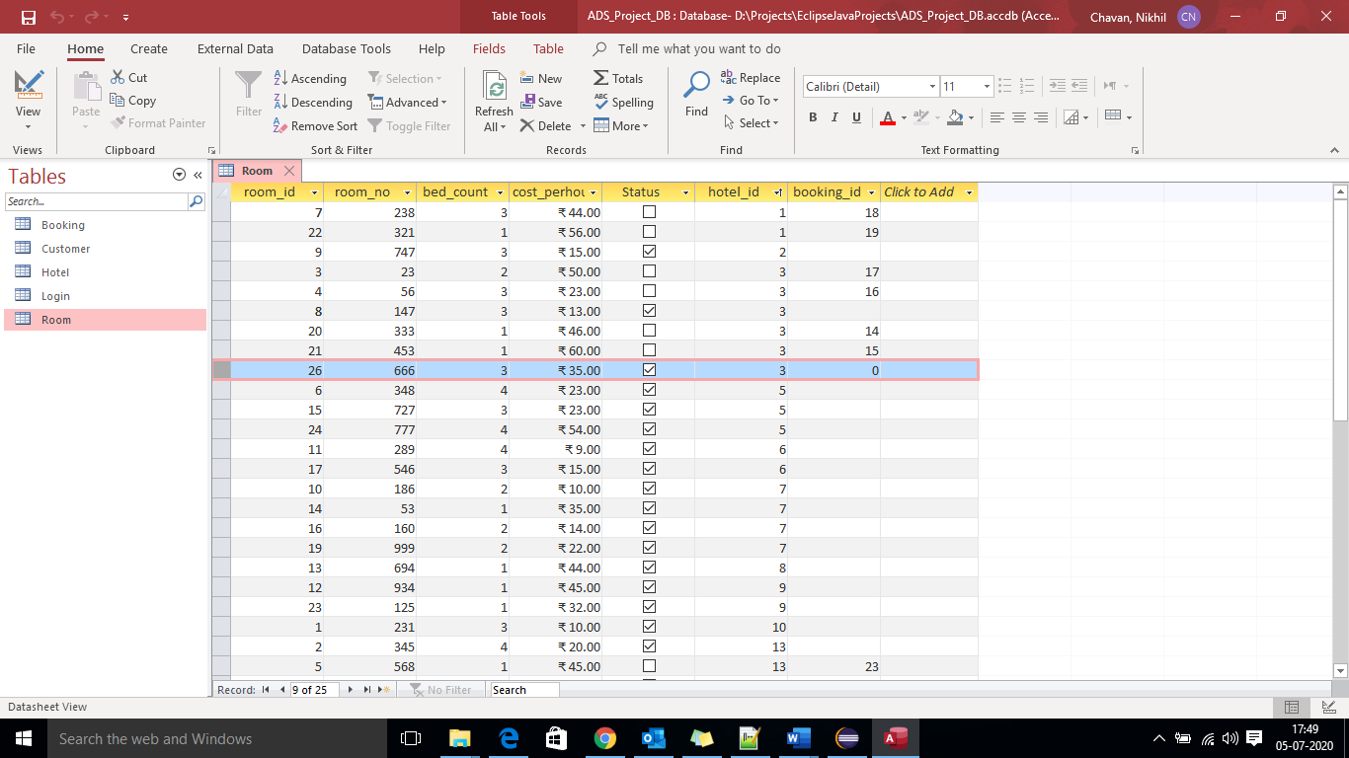

Updating Room ‘666’ cost in Hotel Hyatt at Location USA i.e. changing cost from 35 to 38, above screenshot is before updating and below screenshot is after updating the Room data in Room table

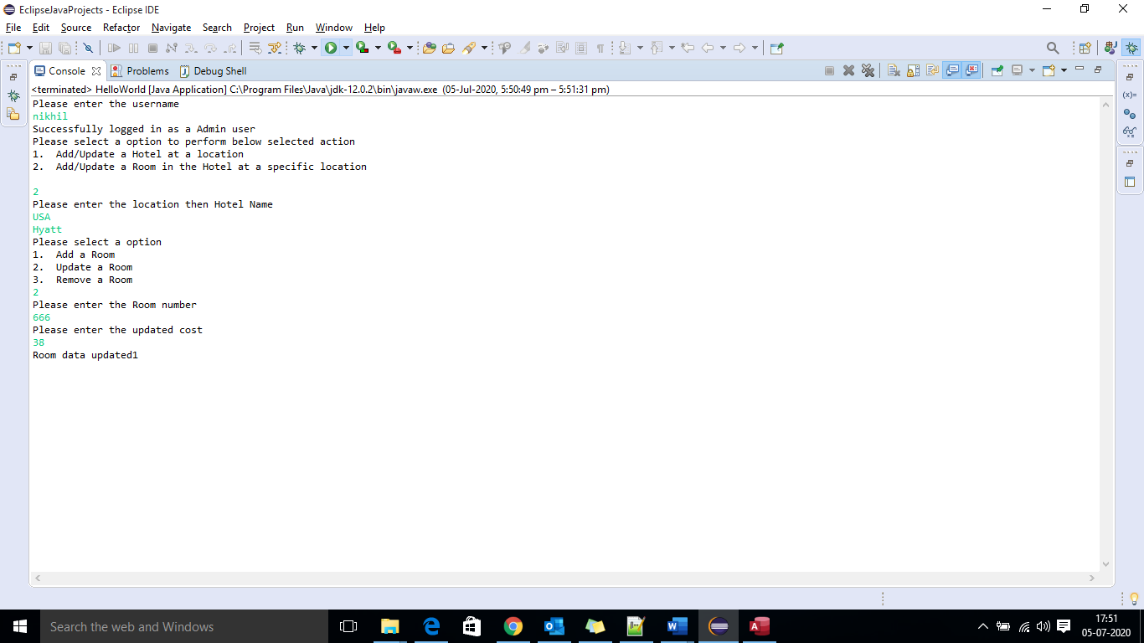

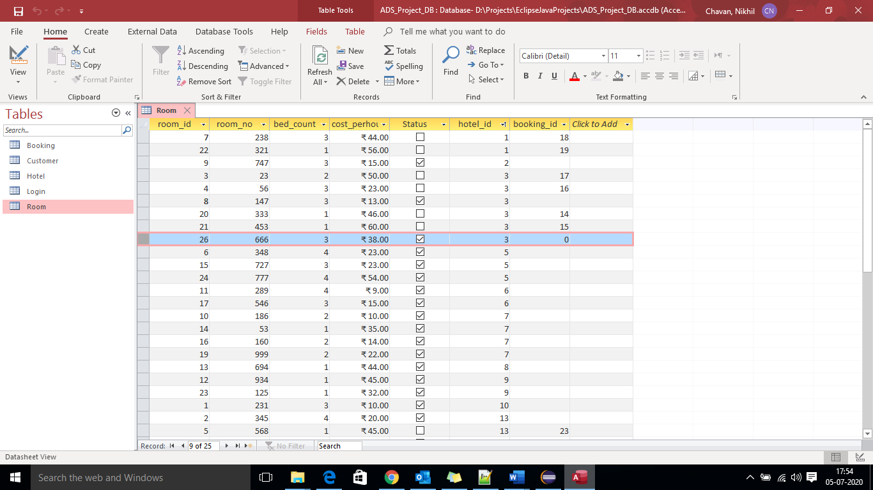

**Deleting the Room ‘666’ in Hotel Hyatt at Location USA:** The above considered updated Room No 666 is now being deleted. Hence the above Room table screenshot before deleting and below screenshot is after deleting the room.

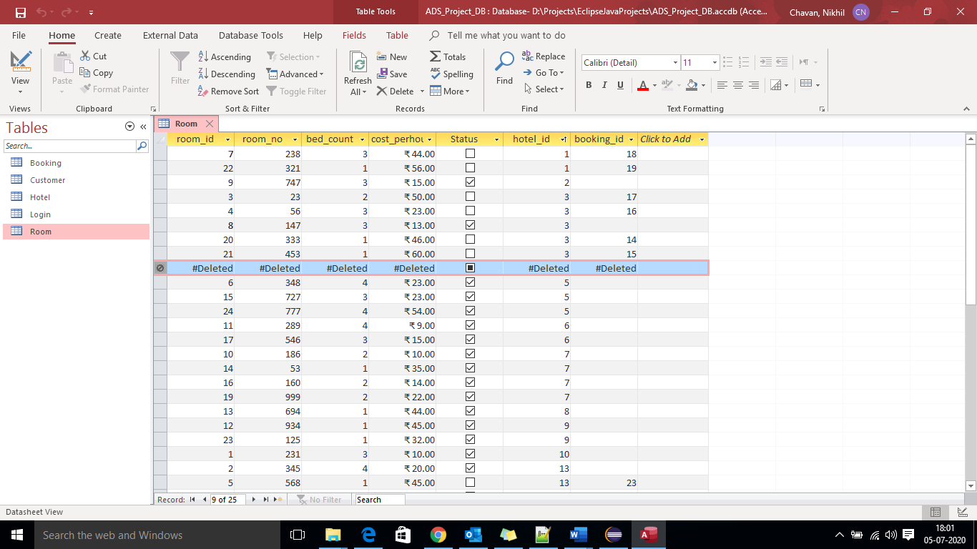

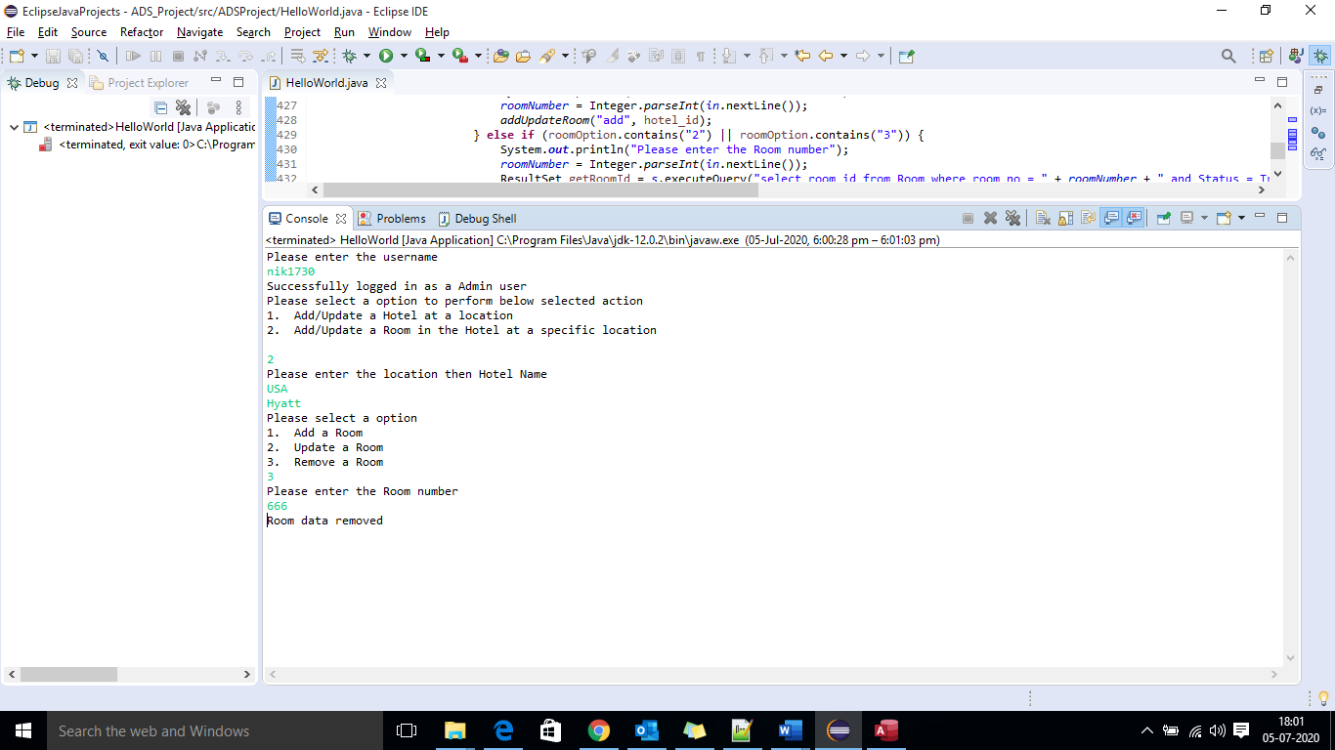

**Search and Book a Hotel Room:** A guest user could able to search for available hotel rooms by hotel location. Upon selecting the hotel, system shows the available rooms and expects for the Room number, in order to book the hotel room. According to the username, a user must enter his personal information if not present in customer table, otherwise system shows the customer details on console by fetching it from customer table, later start date and end date are being entered which are validated, once every validation is successful then system outputs the booking confirmation details. (guest2 trying to book a hotel room in Radisson UK below **highlighted** rows are related to before and after booking screenshots of respective tables i.e. Hotel, Room, Customer and Booking)

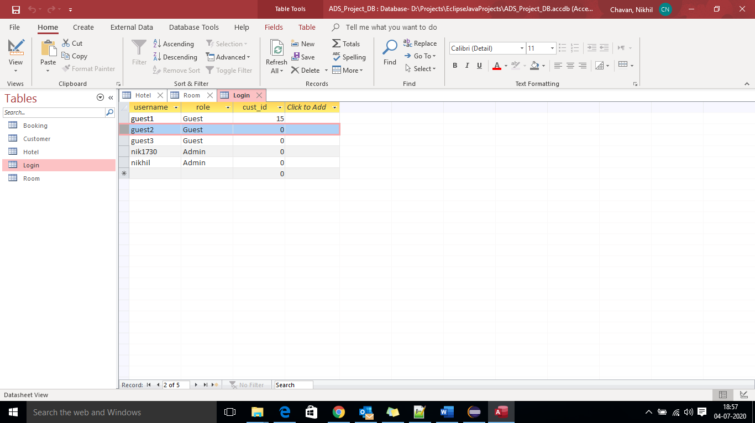 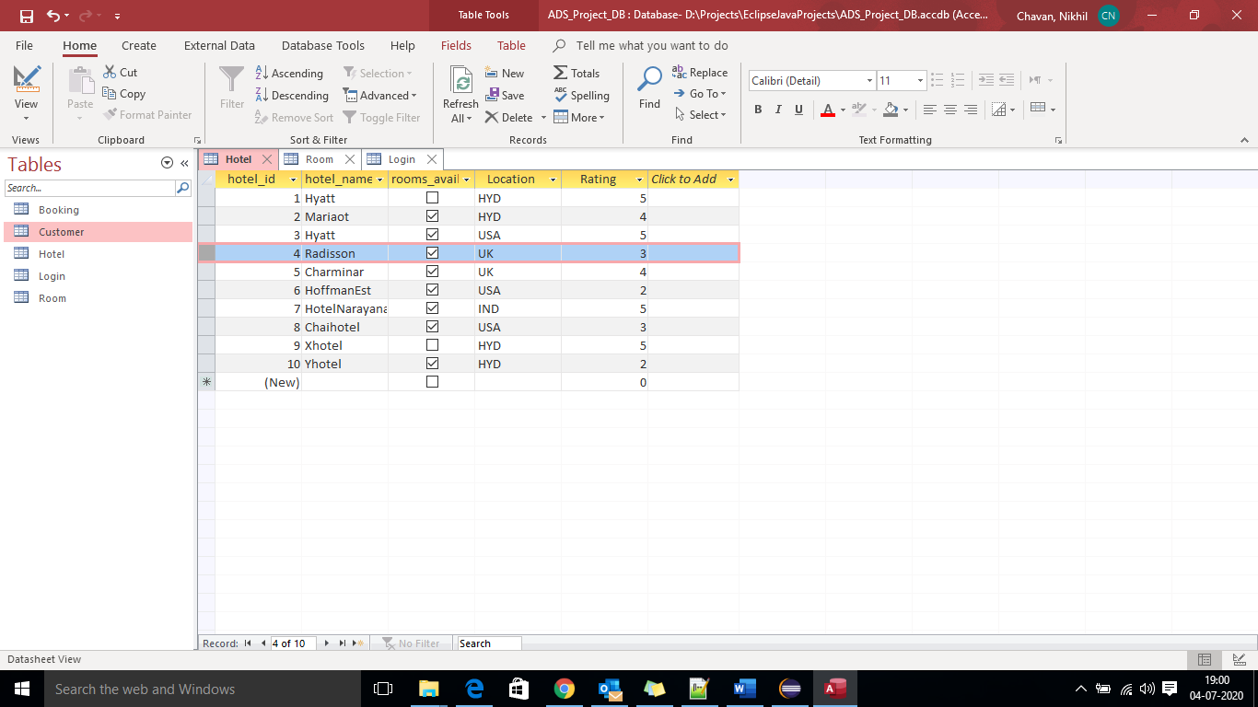

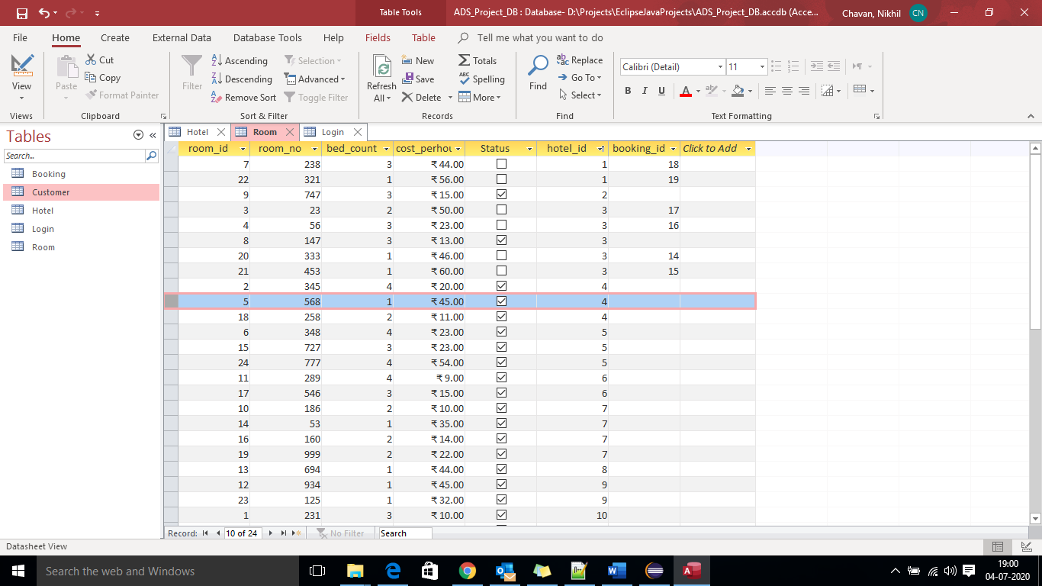

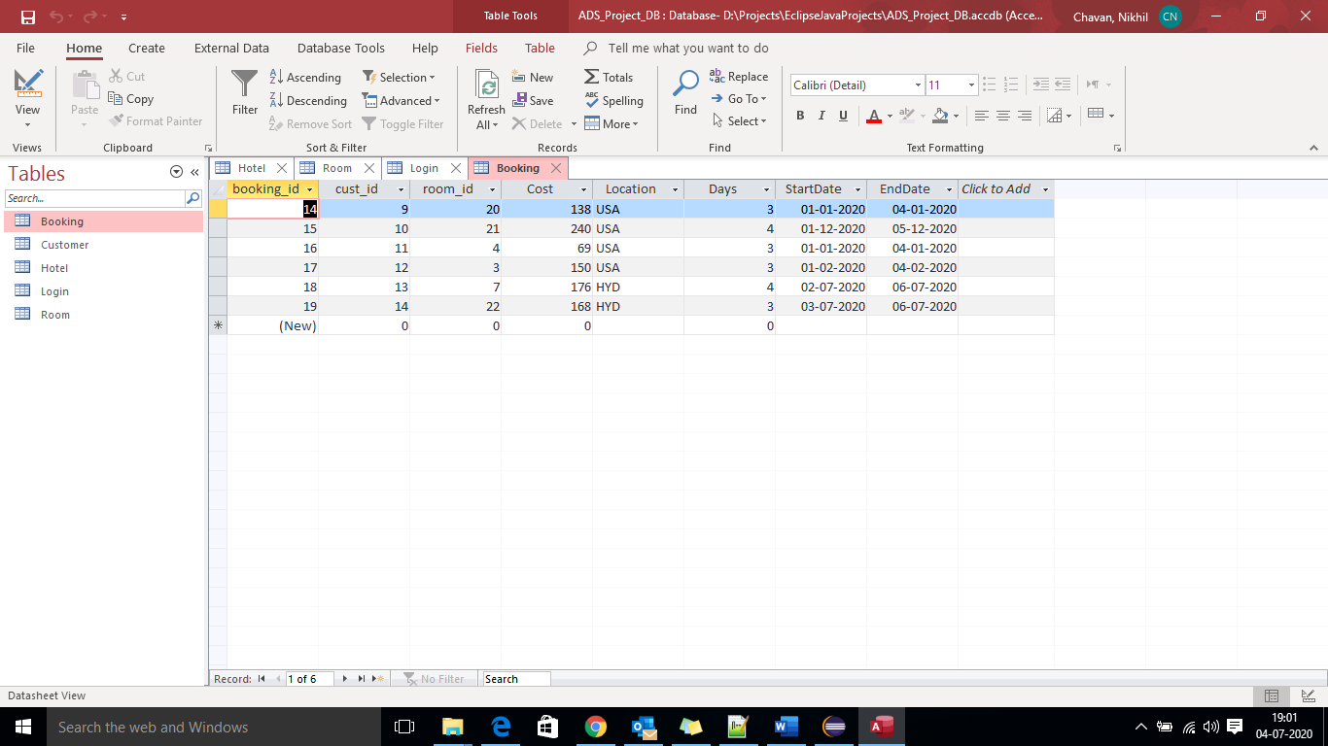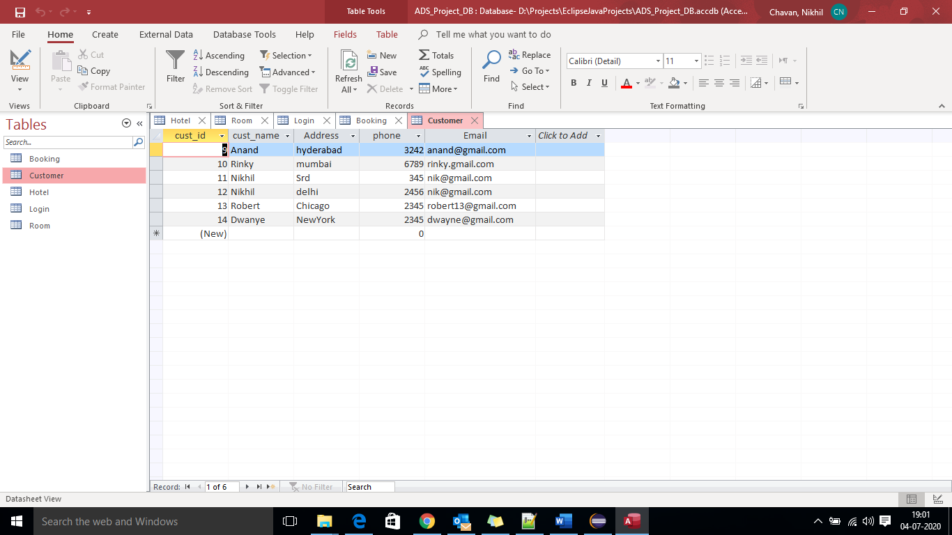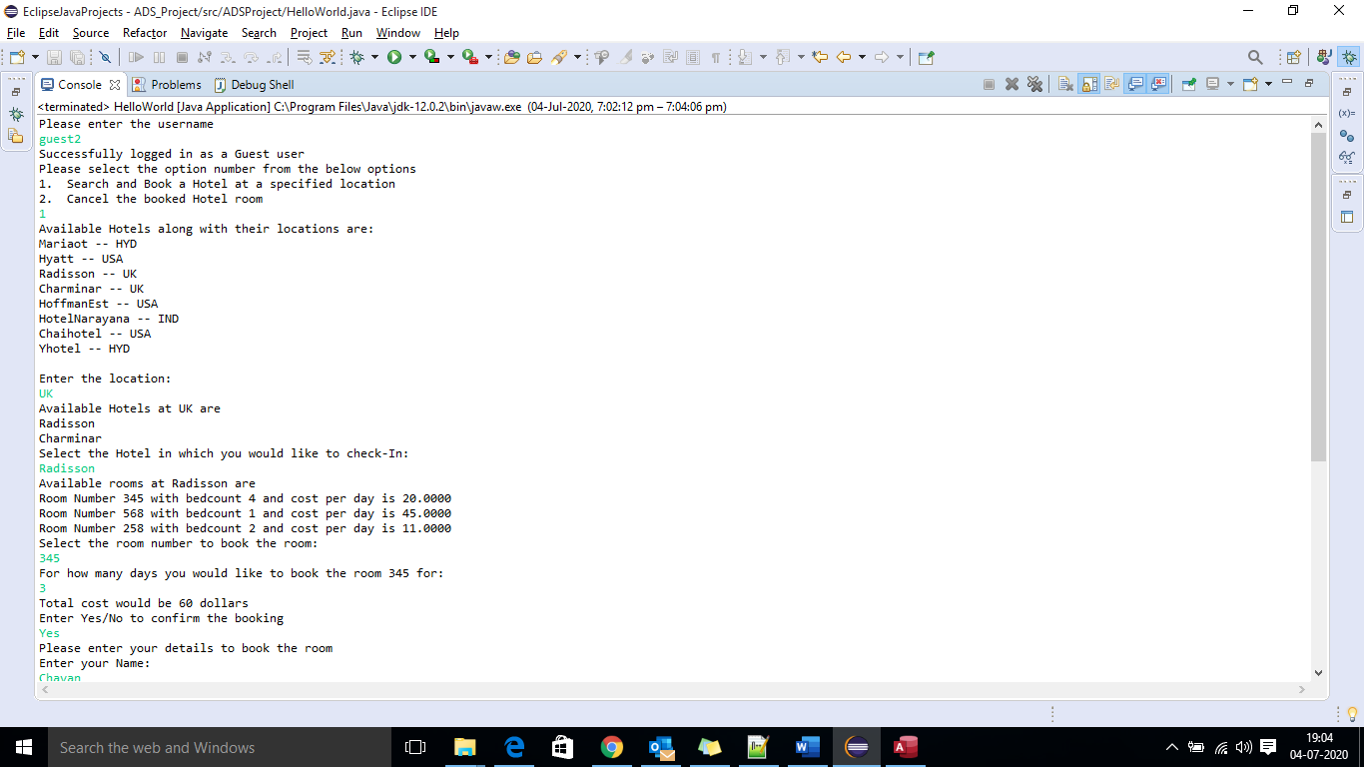

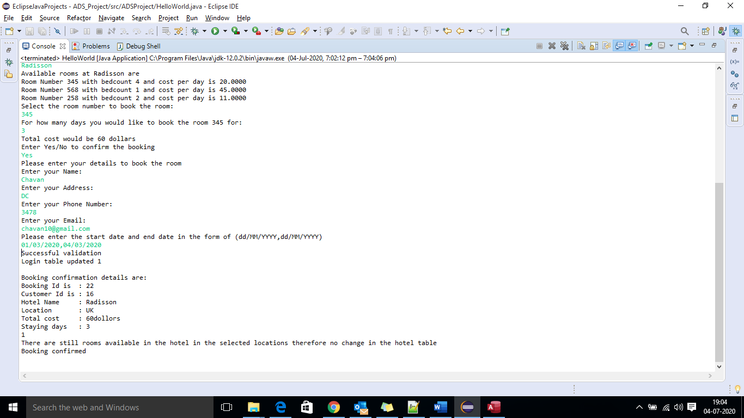

After successful booking the below screenshots with highlighted rows are the updates happened i.e. Customer table is being updated by “chavan” personal details and login table has been updated with cust_id 16, accordingly Booking table is inserted by new row with booking id 22 the same has been shown to the user as booking id, further the in Room table, the status of room number 345 is changed to false and booking id is added in the attribute booking_id in room table (highlighted rows in the below screenshots are the evidence)

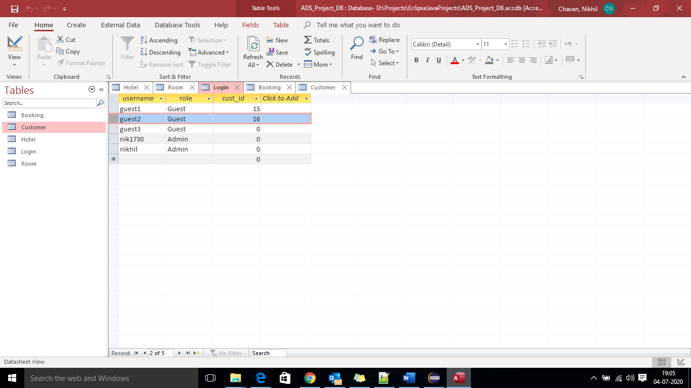 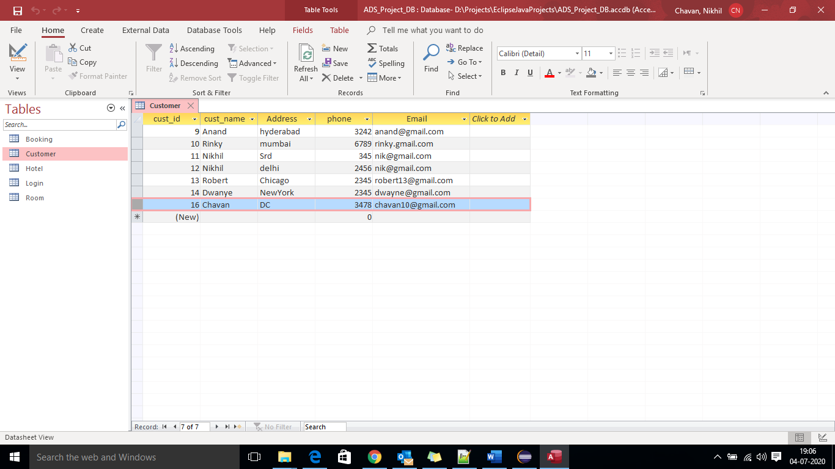

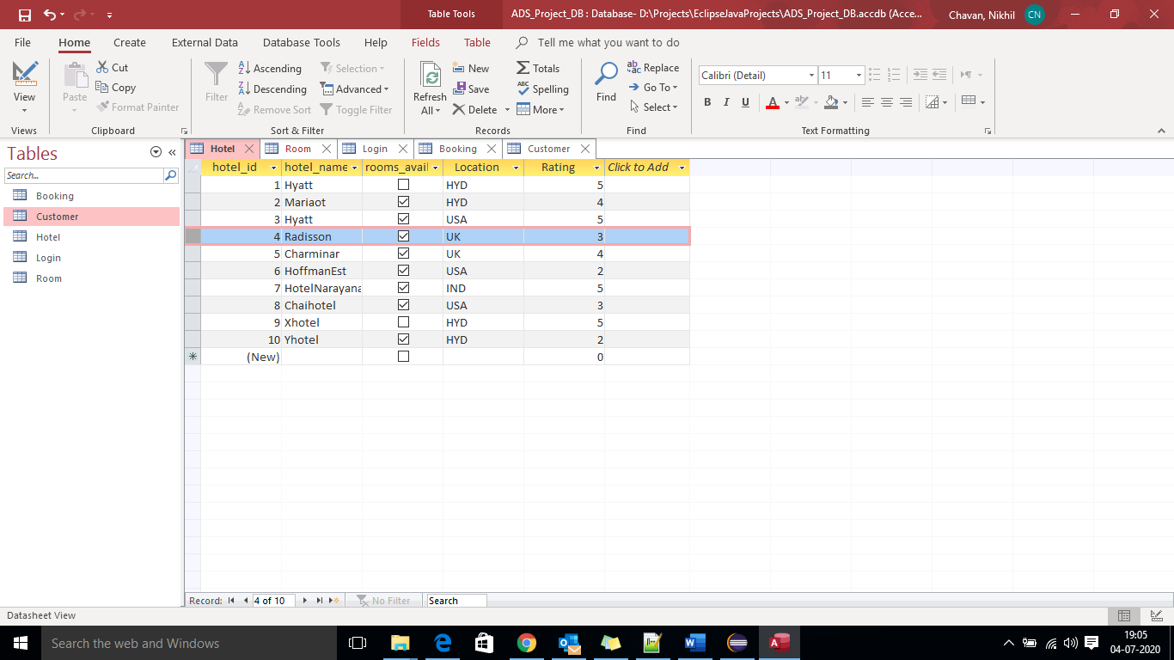

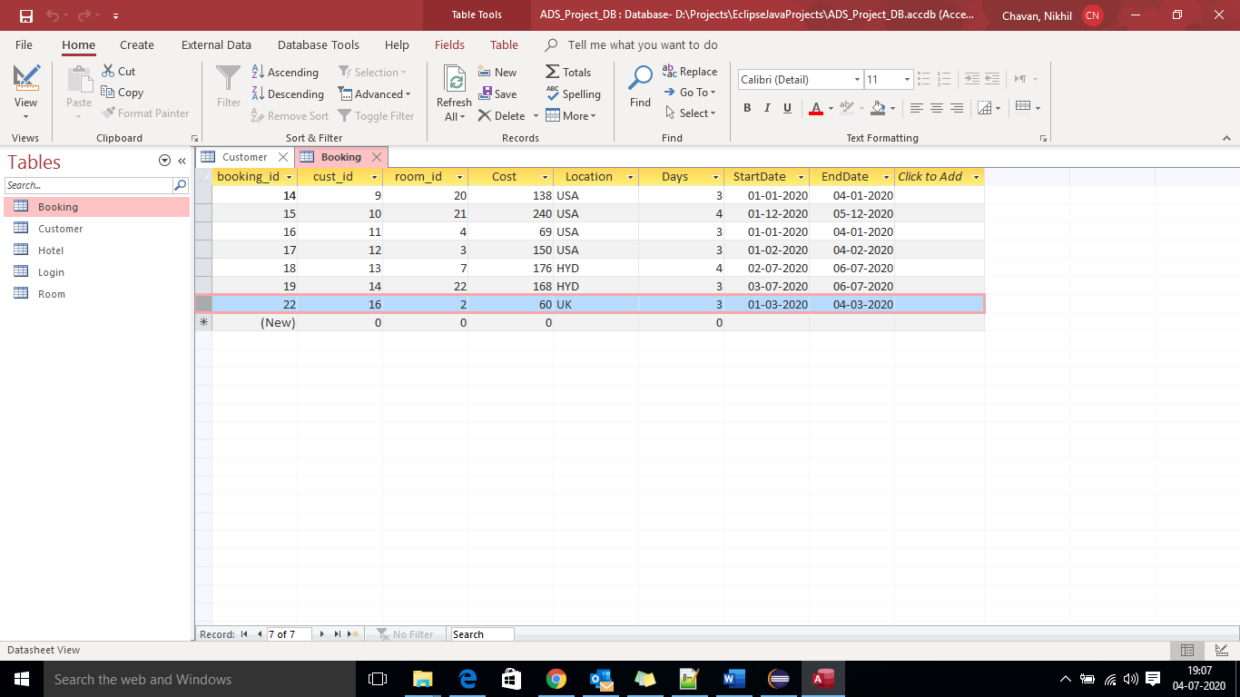

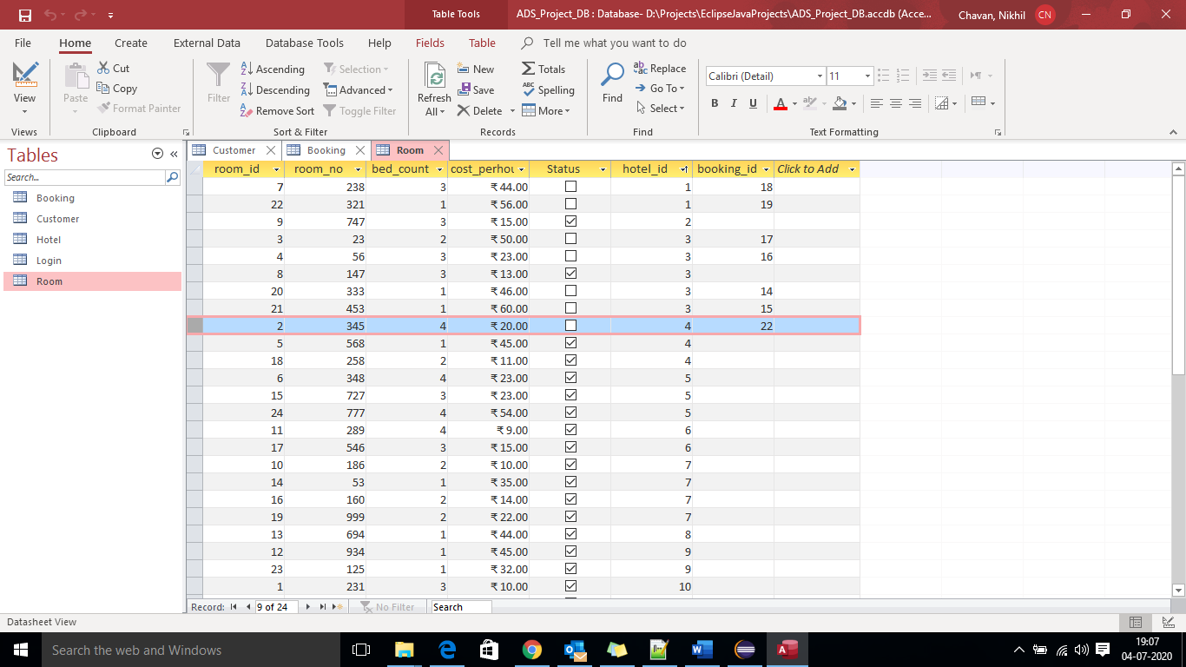

Adding another room for the same guest username i.e. “guest2” for which the user need not have to give the personal details again i.e. it retrieves from the last user login.

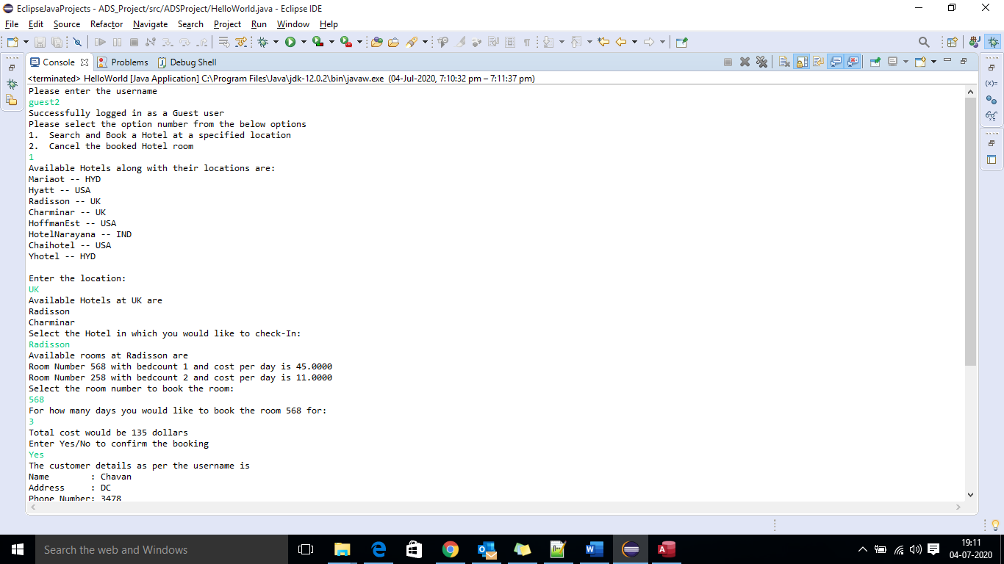

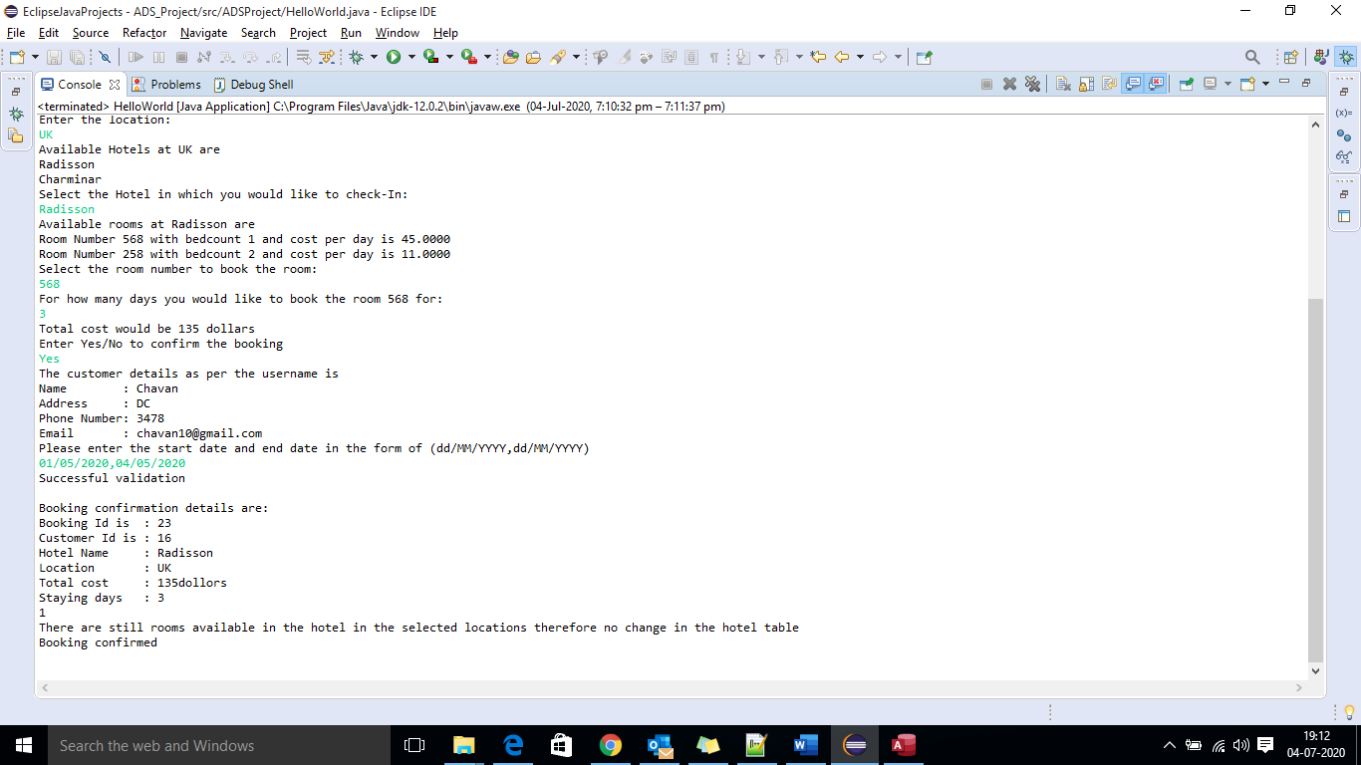

We could see the Room No 568 status is changed to false and booking id 23 is added in the attribute of booking_id in the Room table. The below screenshot is rather considered for the future scenarios.

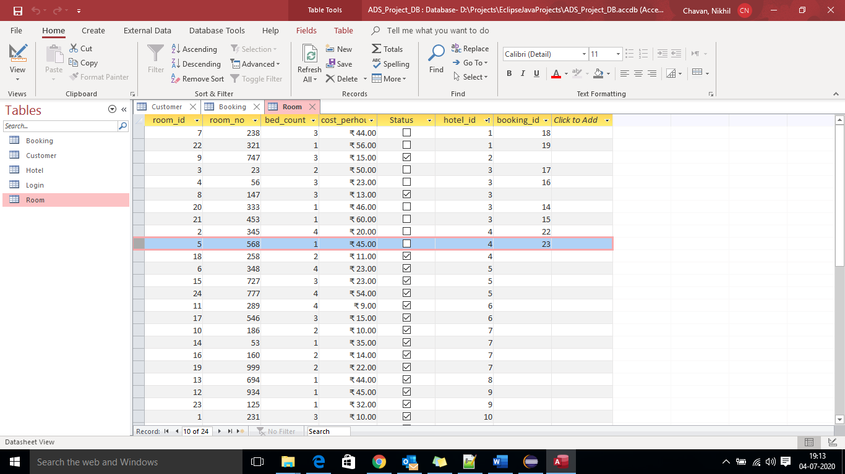

Checking if the Hotel table attribute rooms_available status is set to false i.e. if all the rooms in the hotel are booked, trying for guest1 user and Radisson only has one room available and trying to book the room in Radisson, the same is evident in the above screenshot where the room number 258 has status true which is present in Radisson which has hotel_id 4 (below the highlighted row in the above Room table screenshot) would meet the scenario the below screenshots shows the all the table screenshots after performing the action i.e. 258 is updated in Room table with its status and booking_id details, the same booking_id has the customer id and booking information in the Booking table and since the username “guest1” tagged with cust_id 13 details are already present the Customer table, the same has been showed in the console. Finally, the last screenshot shows the Radisson status is set to false, which was what meant to happen if no rooms are available in the Hotel it should not be shown when other guest user searches for the hotel at the UK location then Radisson shouldn’t be shown to the user.

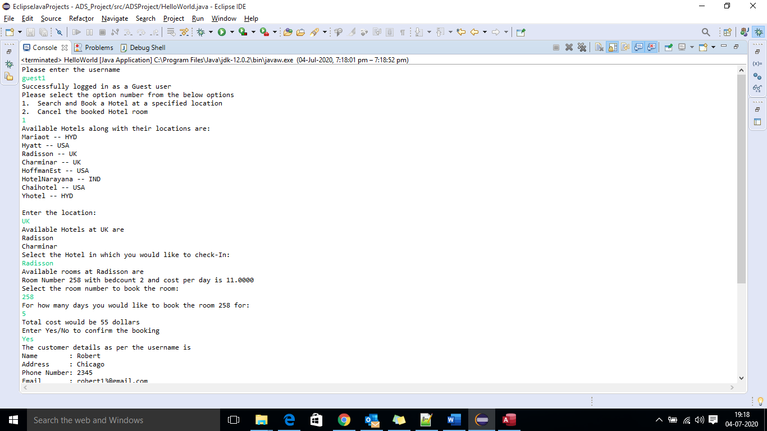

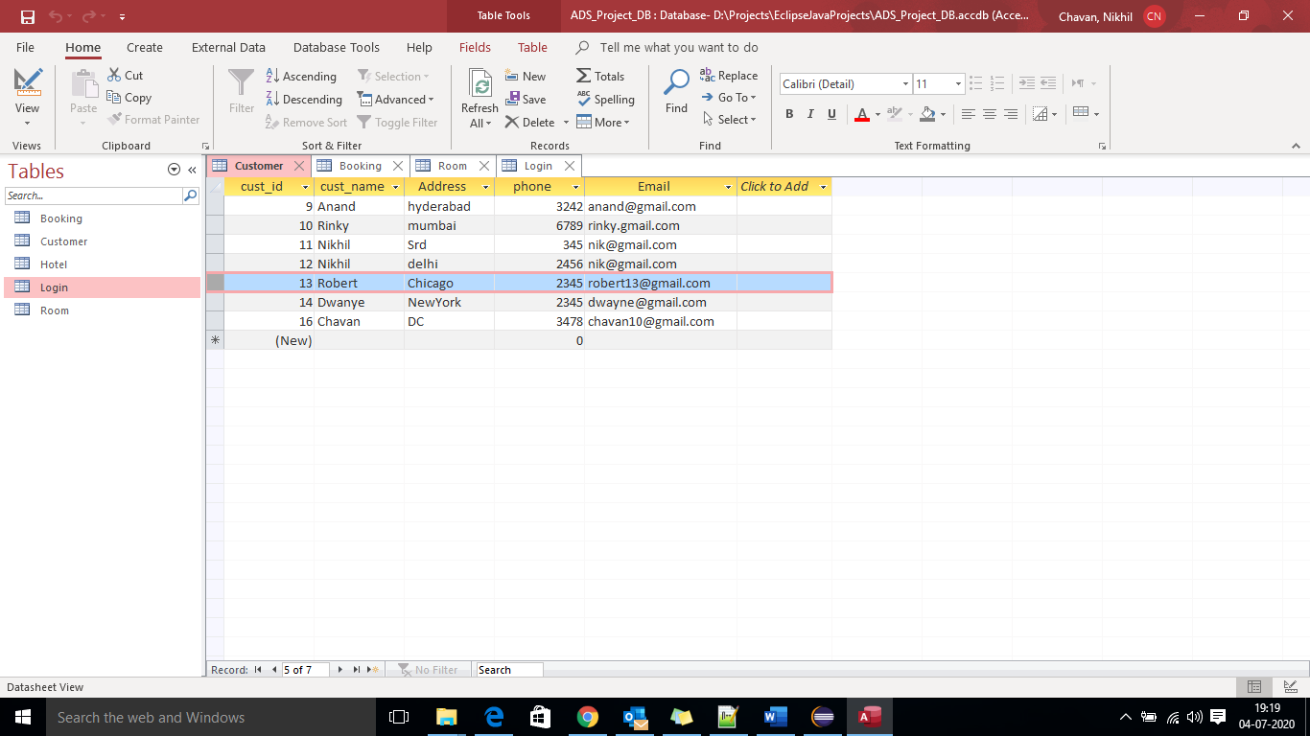 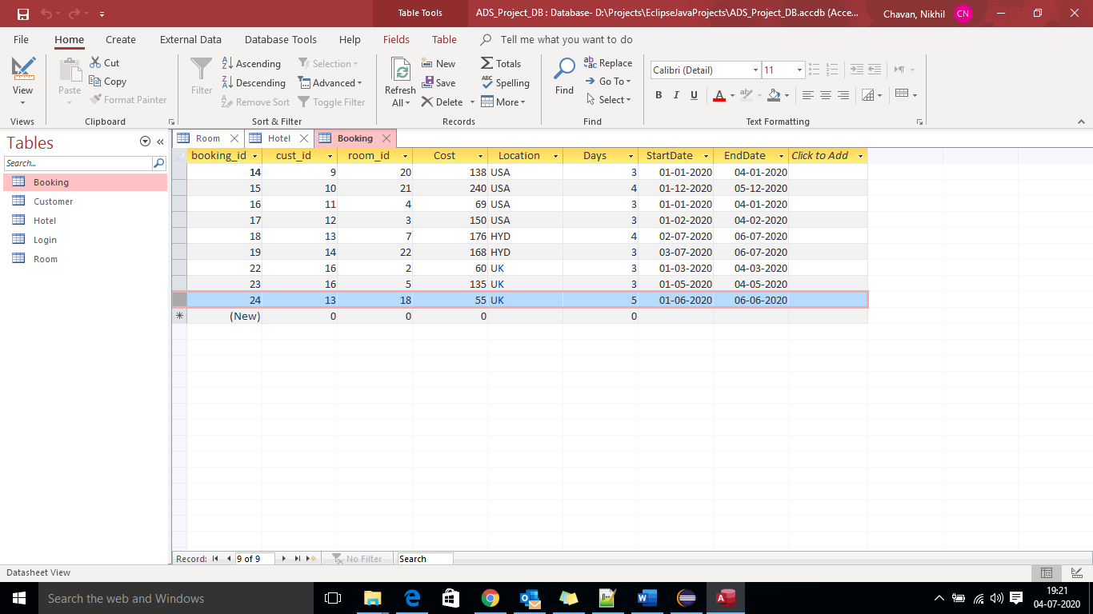

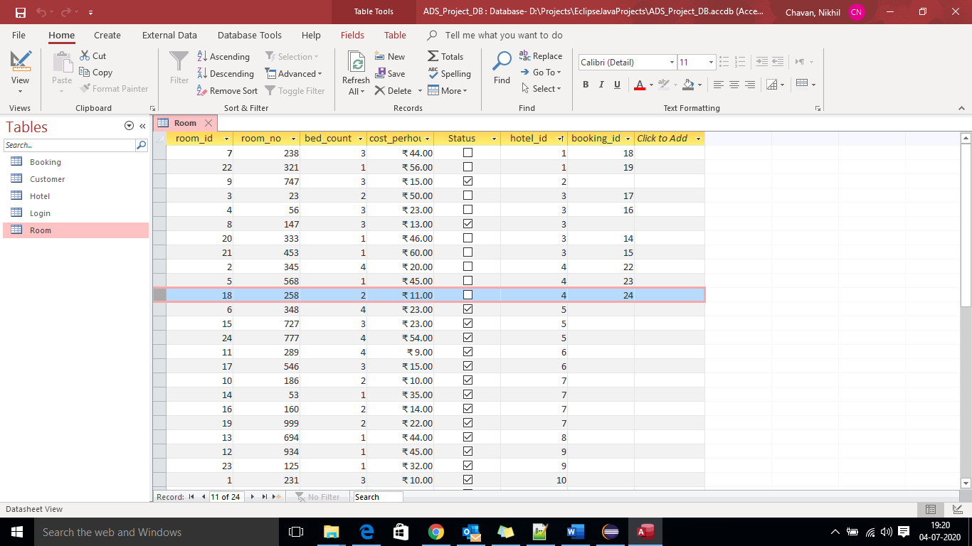

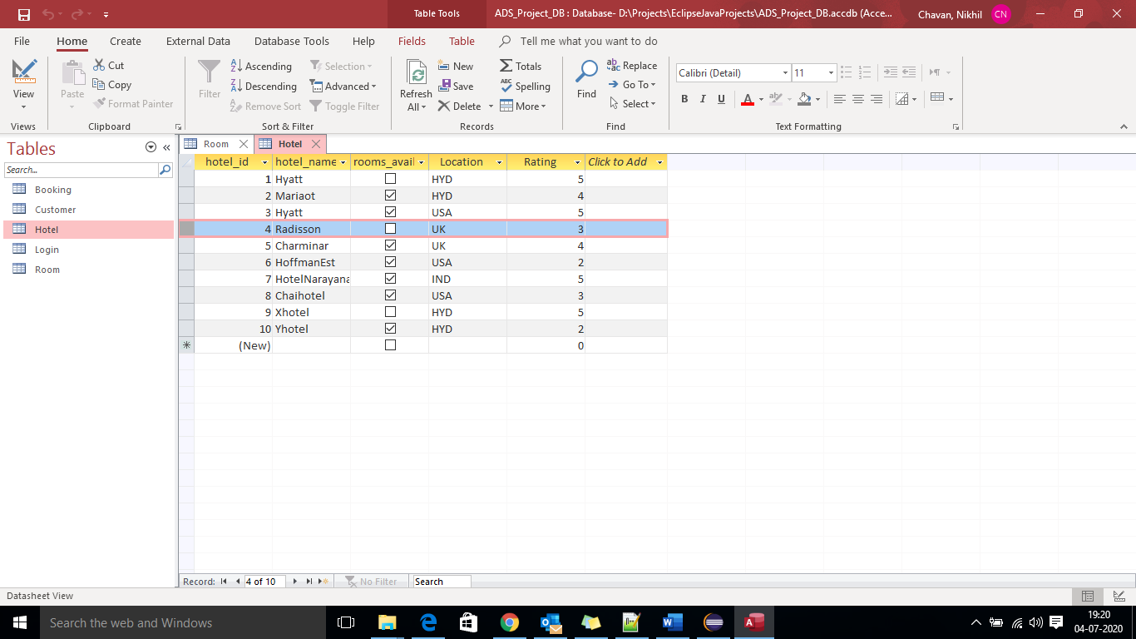

**Cancellation of Booked Room:** When user enters as a guest user the system shows all the booking ids on the basis of username then user has to provide the booking id, accordingly the updates happens in Room table where the status is shown true, Hotel table the room available table is set true again, No change in the customer table, Booking table the booking id information is deleted (not a soft delete it’s a permanent delete). The system outputs the cancellation confirmation. Below screenshots shows how the console shows all the available bookings for username “guest2” with cust_id has 16 has 2 bookings with booking id 22 and 23 with room_id attribute 2 and 5, the other screenshots are understood accordingly.



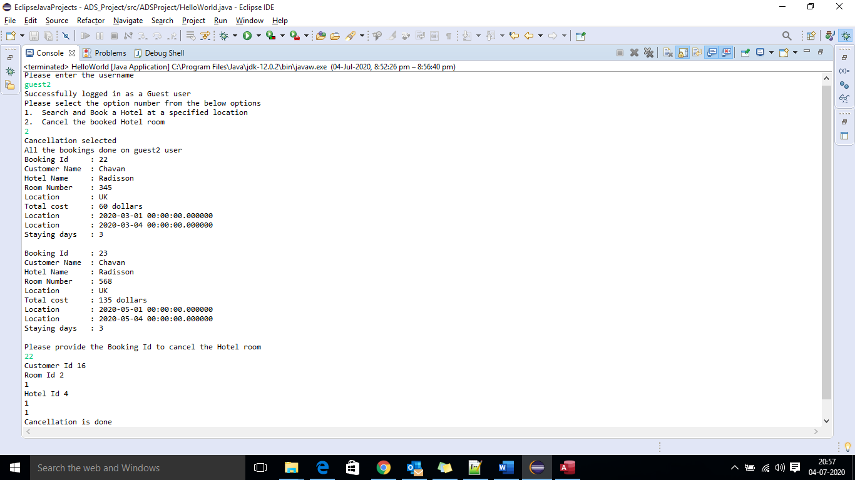

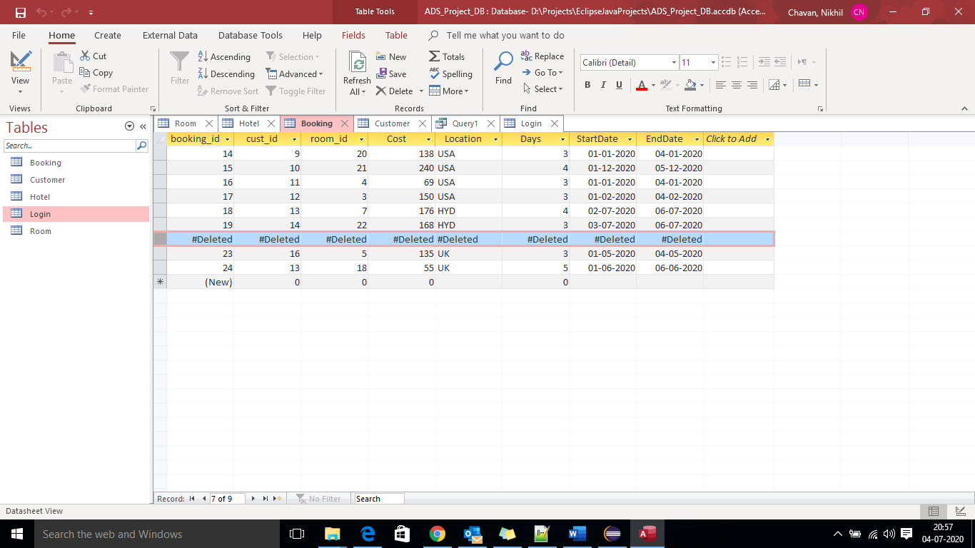

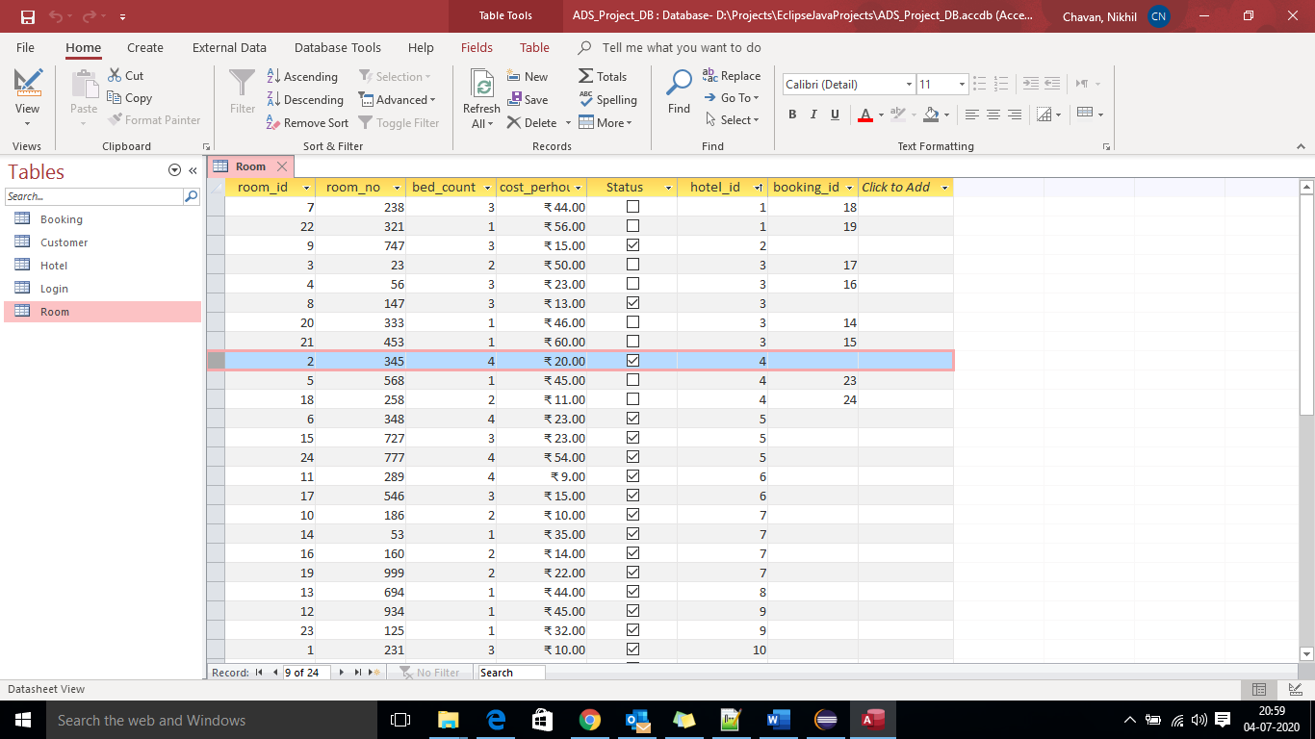

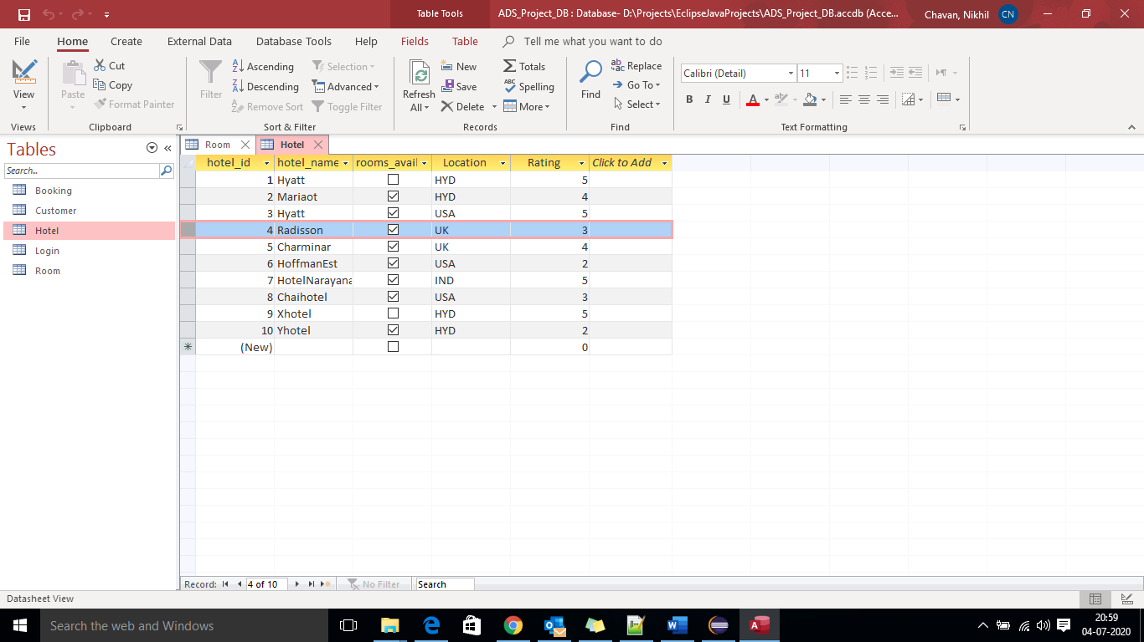

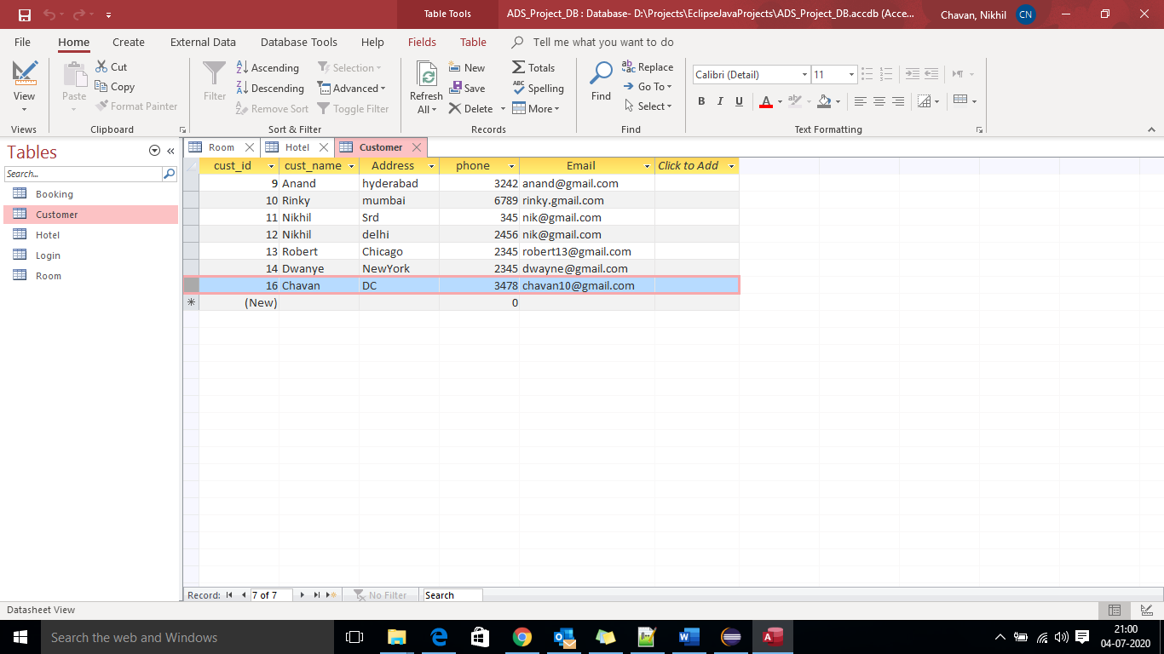

**Edge cases:**

If username entered is not a valid username i.e. not present in the Login table, then it shows username entered is incorrect.

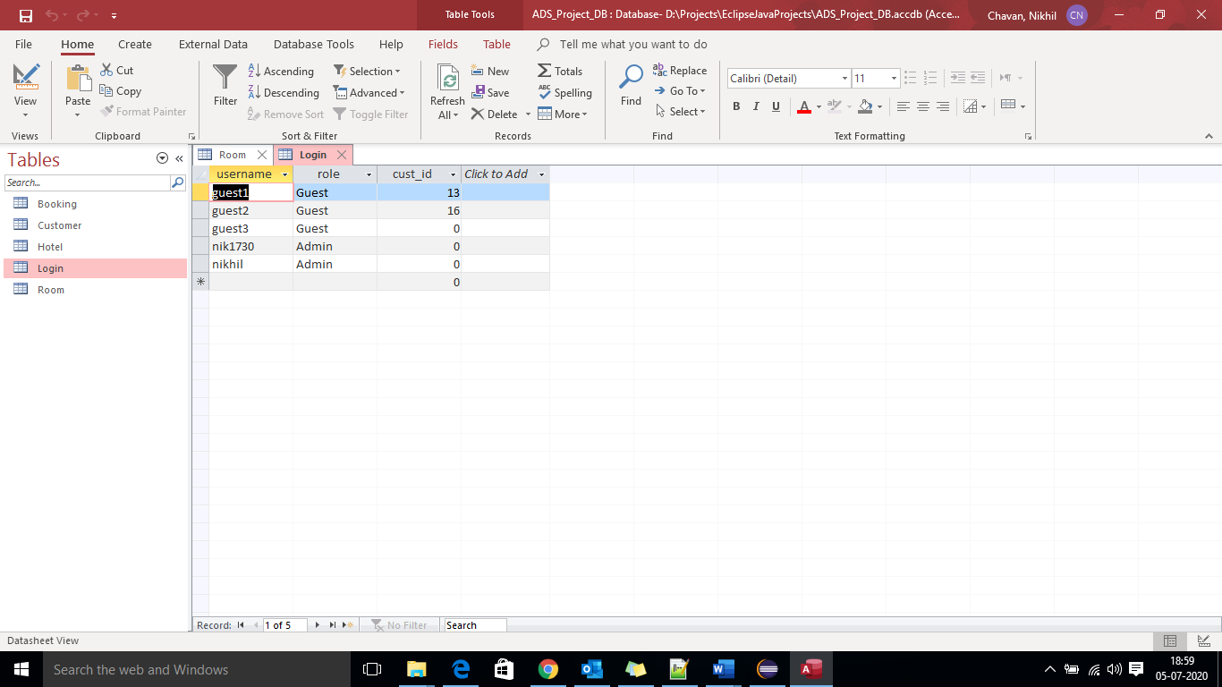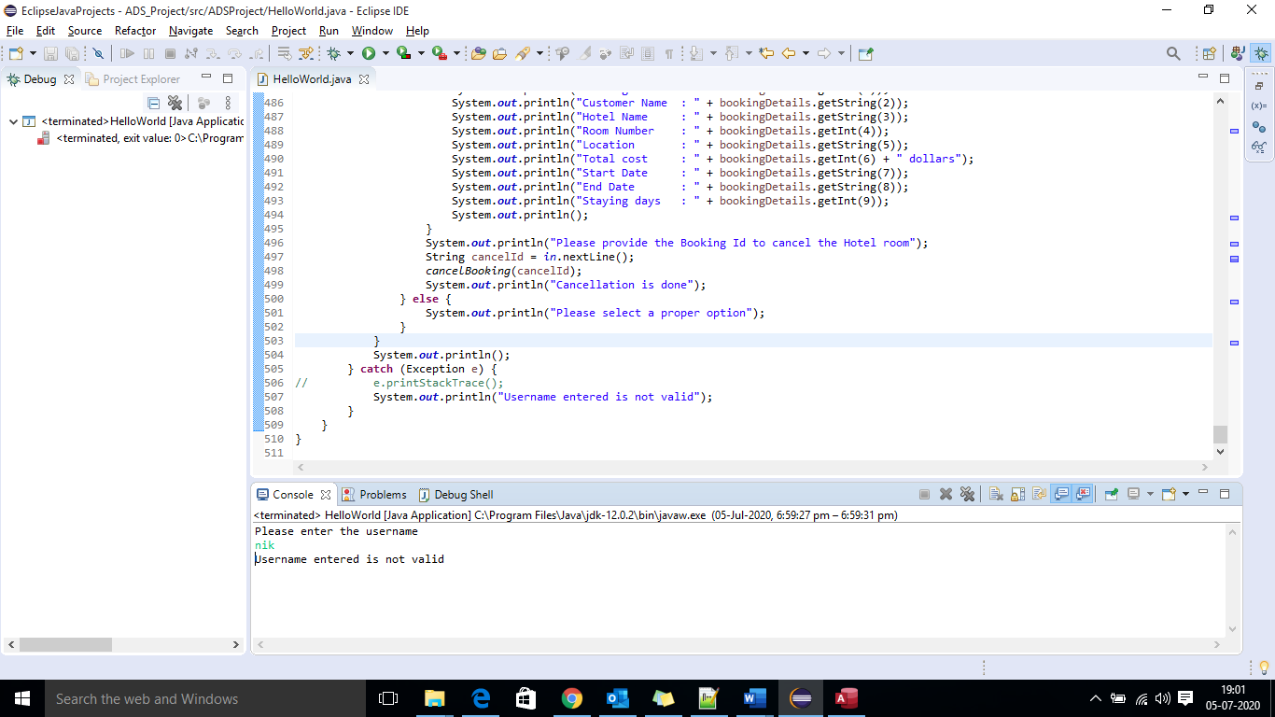

When entering incorrect option then system outputs as Incorrect option entered.

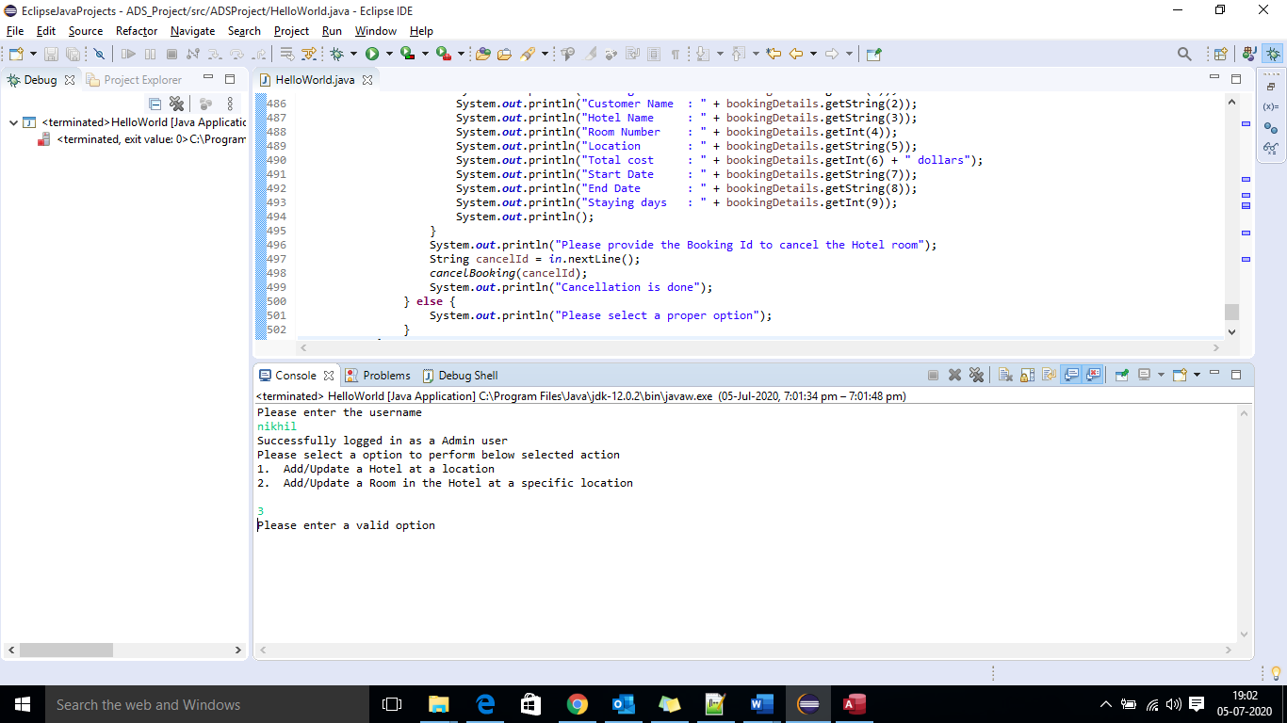

When entering a wrong location as Admin user

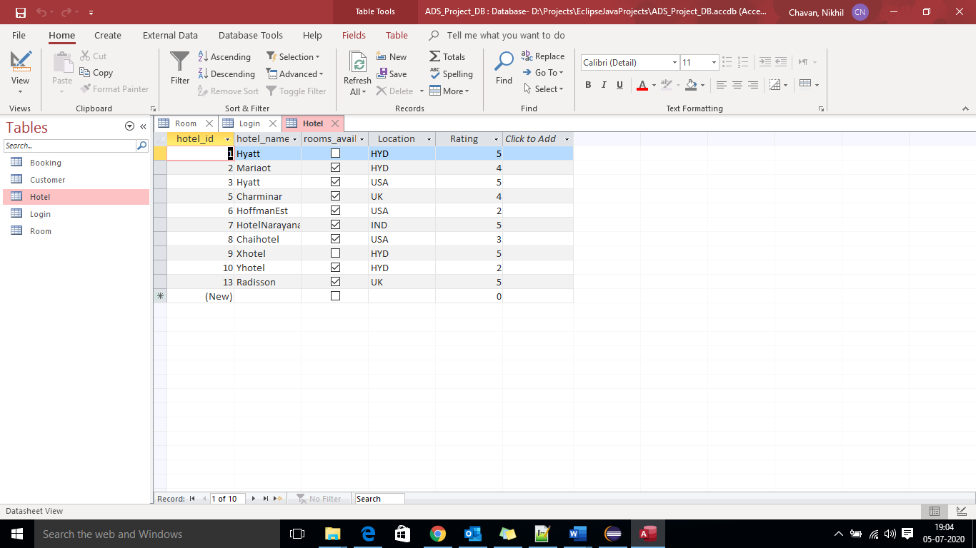

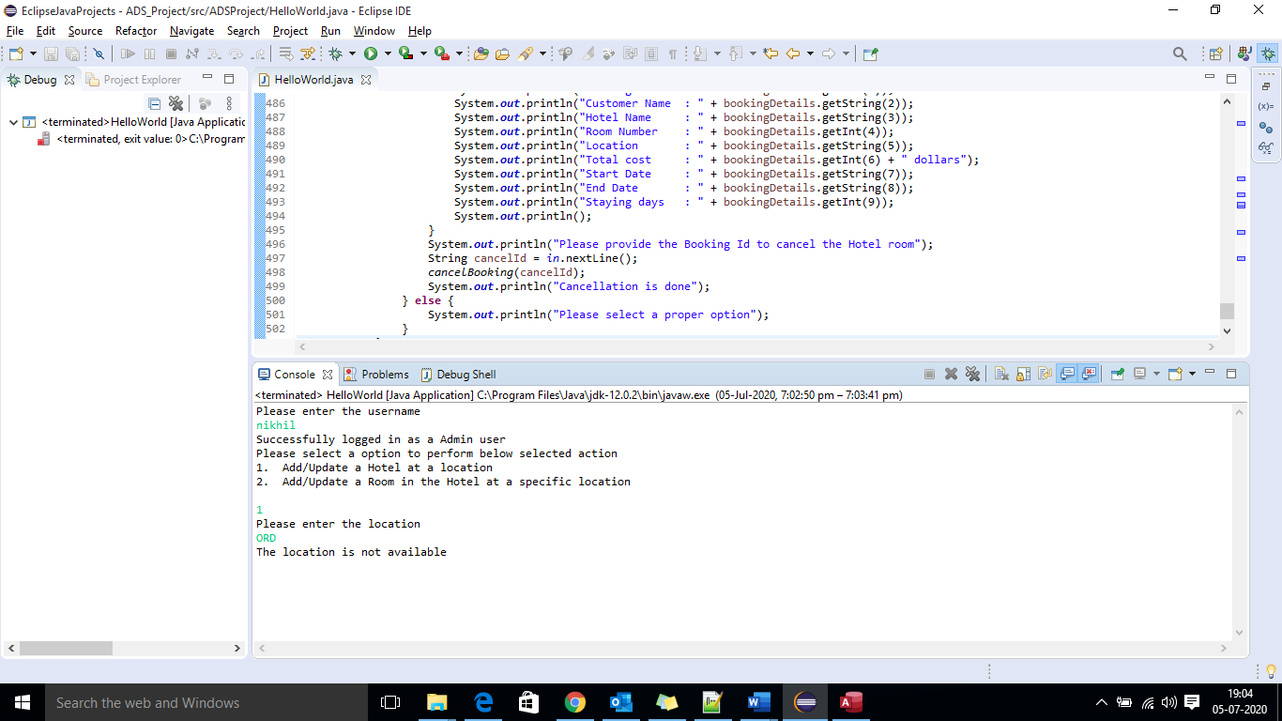

After entering a correction location and incorrect option for performing actions as a Admin user in either related to Hotel or Room updations.

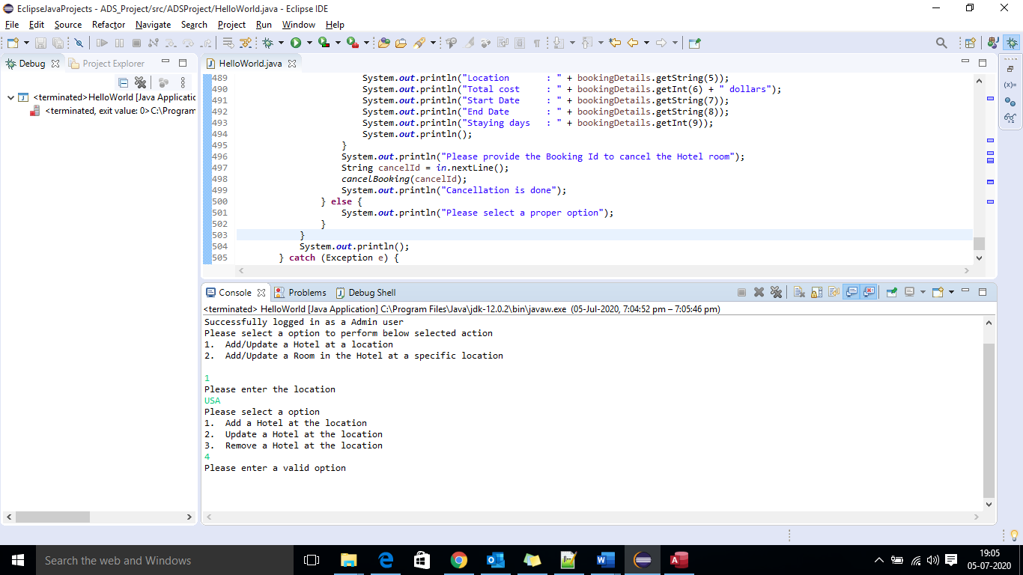

Entering Wrong Hotel name at a correction location

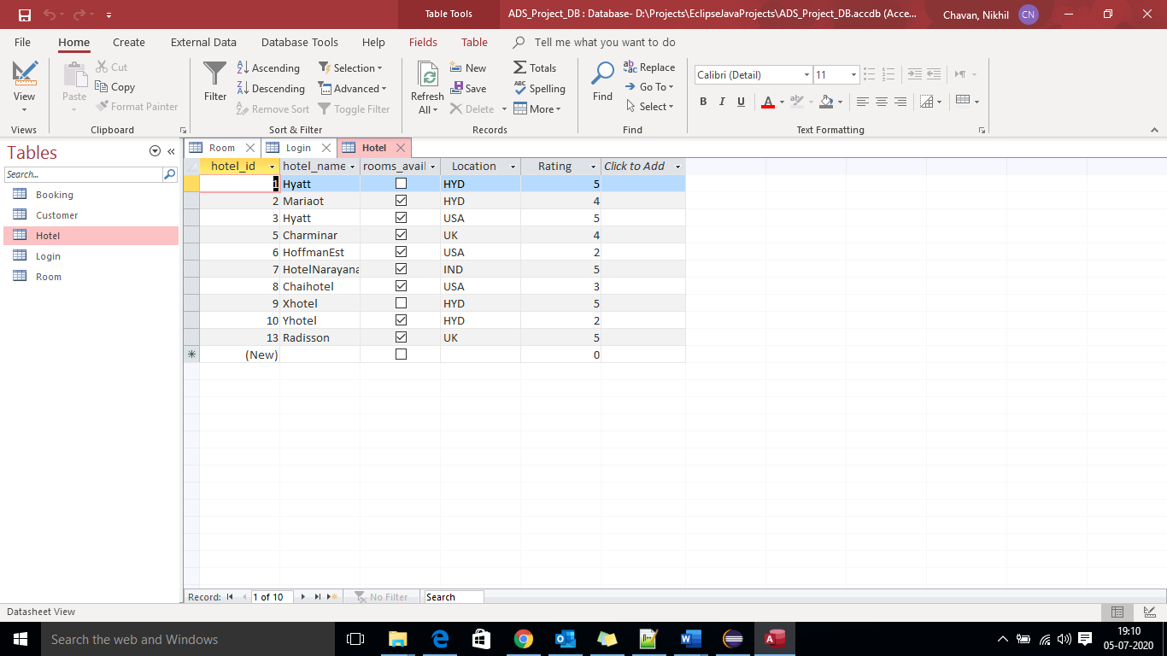

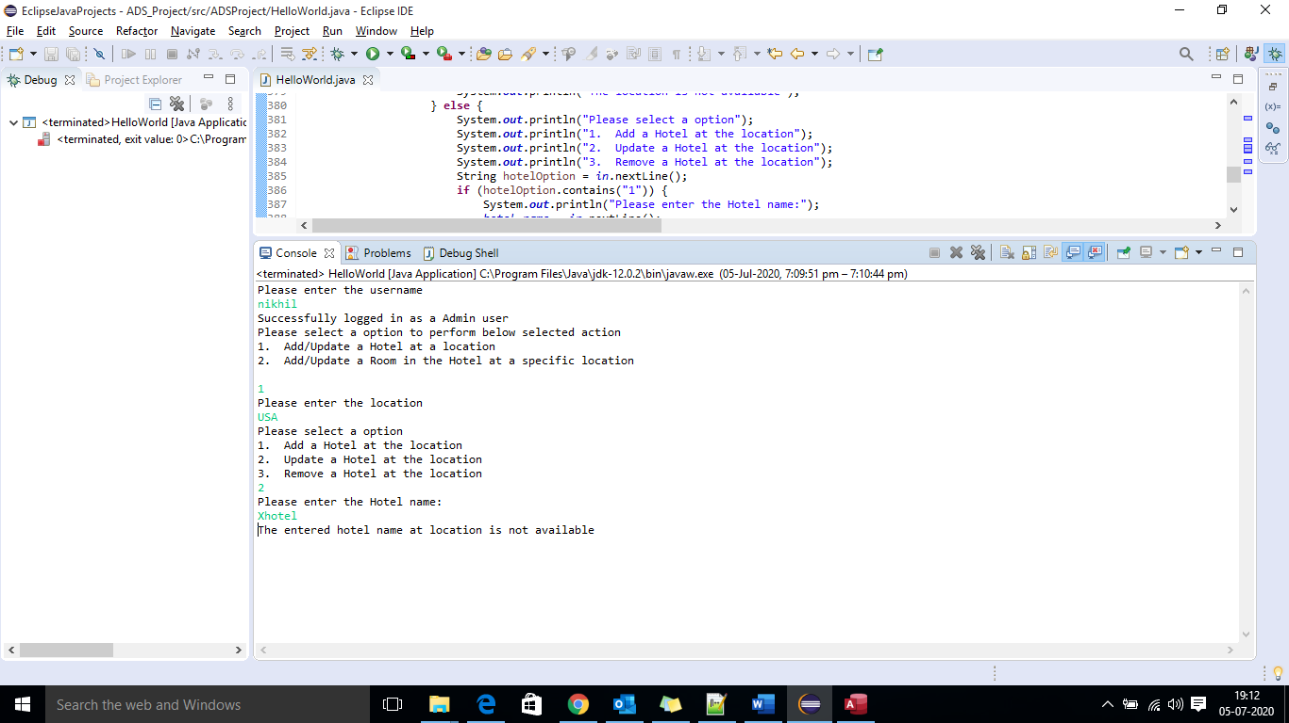

Doesn’t delete the hotel if the rooms are booked in the hotel (Checking for Radisson Hotel in UK in which the room numbers 568 and 258 are booked)





While updating or deleting a Room at a valid Hotel name and Location, if a invalid room number is provided by the admin user then system throws the error message.

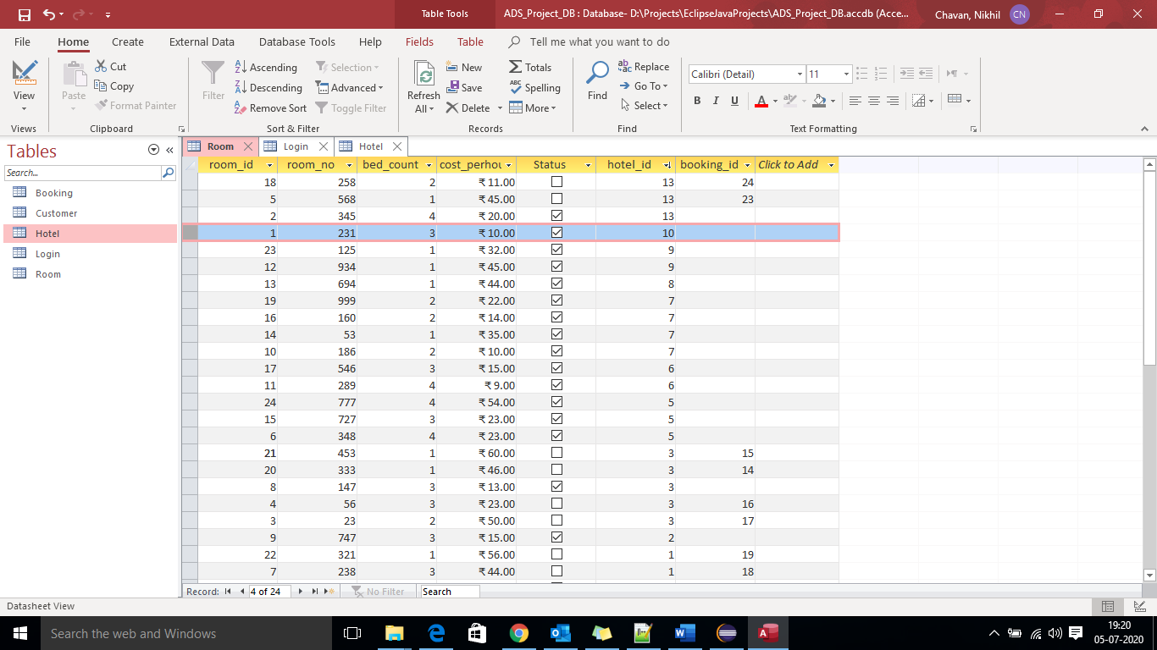

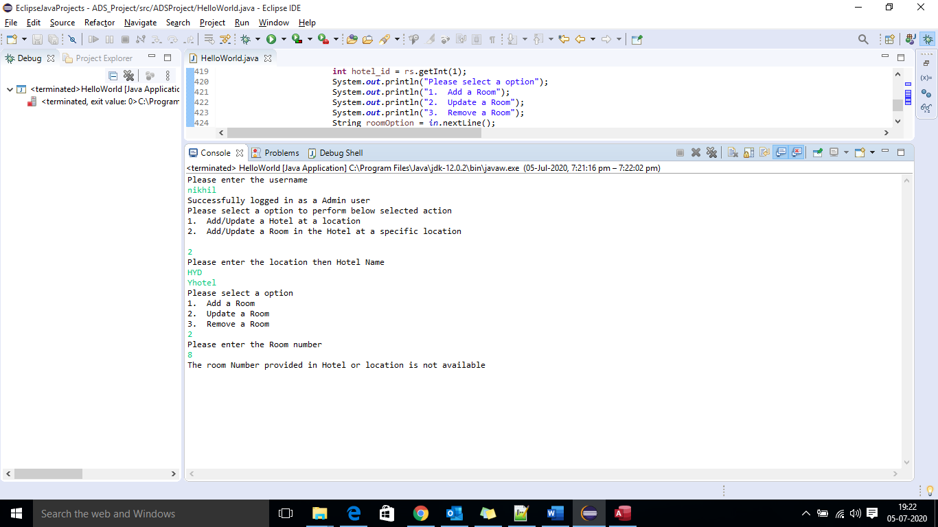

If the Guest user is logged in and tried to book a hotel room, then the system outputs the message as “There are no available hotels at any locations” if all the rooms in all the hotels at different locations are booked.

If there are no hotels available at a specified location, the system outputs as “There are no hotels available at the user_location location”. When a wrong location is entered by the guest user then system outputs as below screenshot.

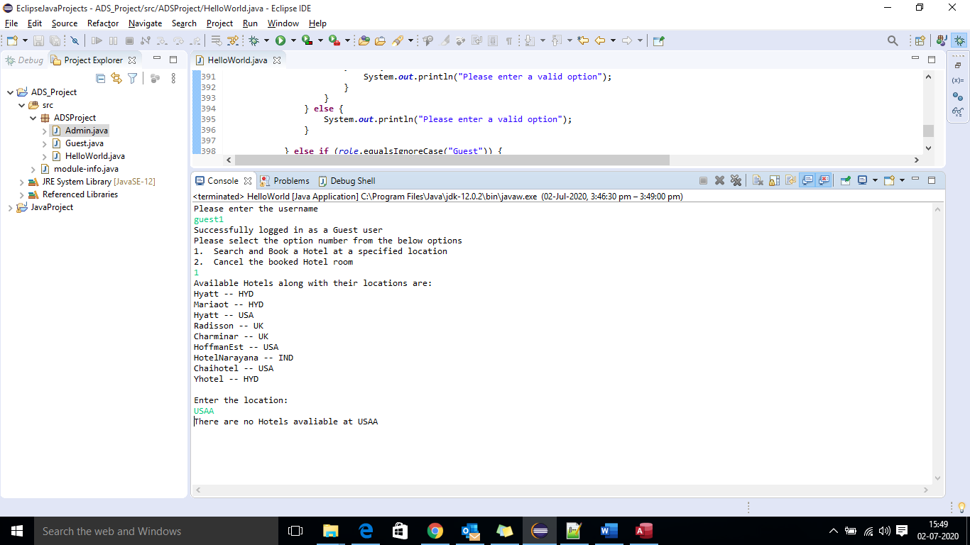

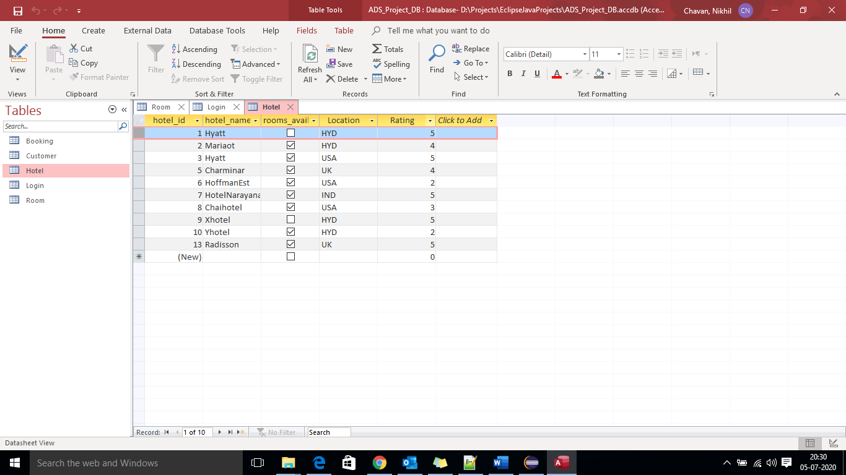

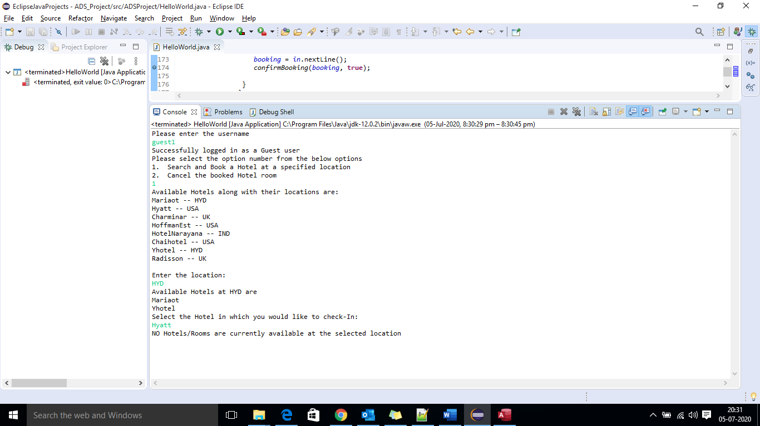

When user selects the Location, Hotel Name, Room Number according to the bedroom specifics, still the system asks for the confirmation whether to book the room or not. If “No” is entered, then the booking process ends.

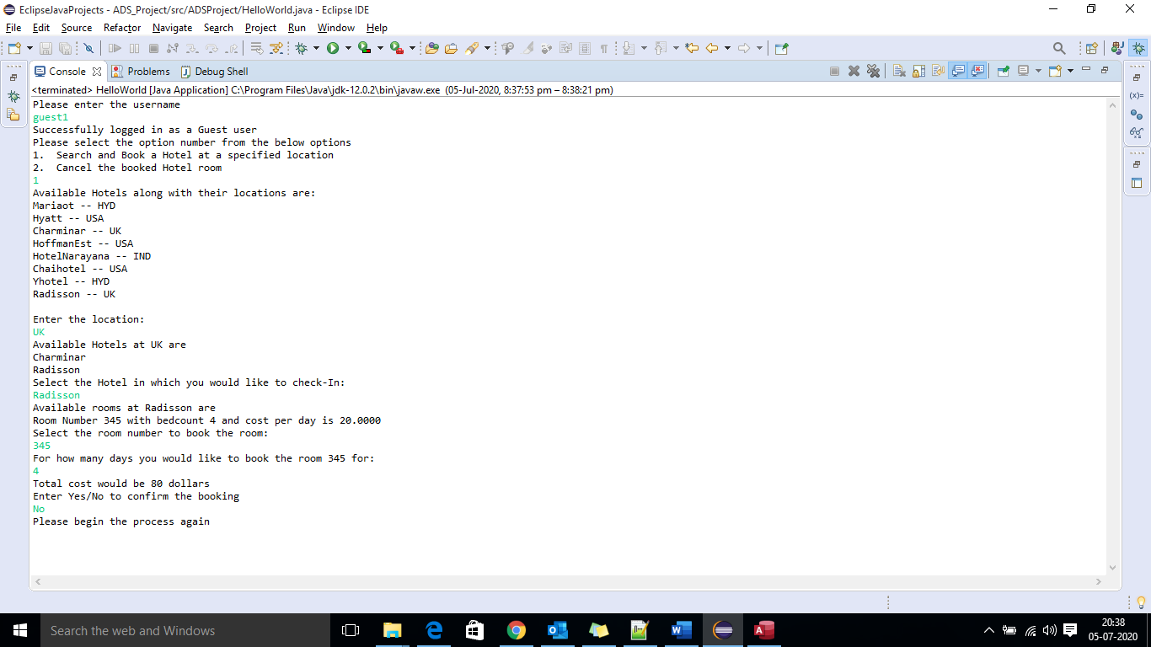

After user confirming for the booking by entering Yes. If start date and end date format entered by the guest user, then system throws the error.

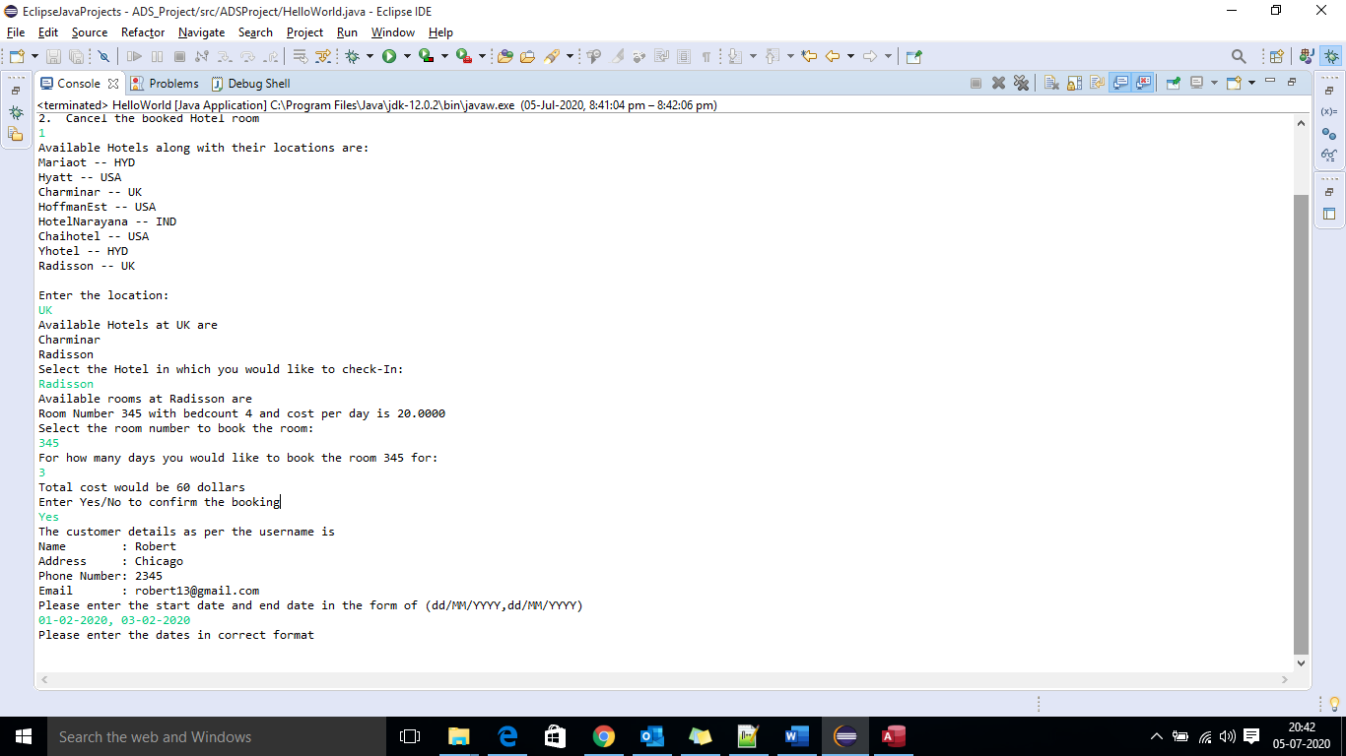

If the number of days of stay entered by the user and the start date and end date difference doesn’t match, then too systems throws error message (Date validation)

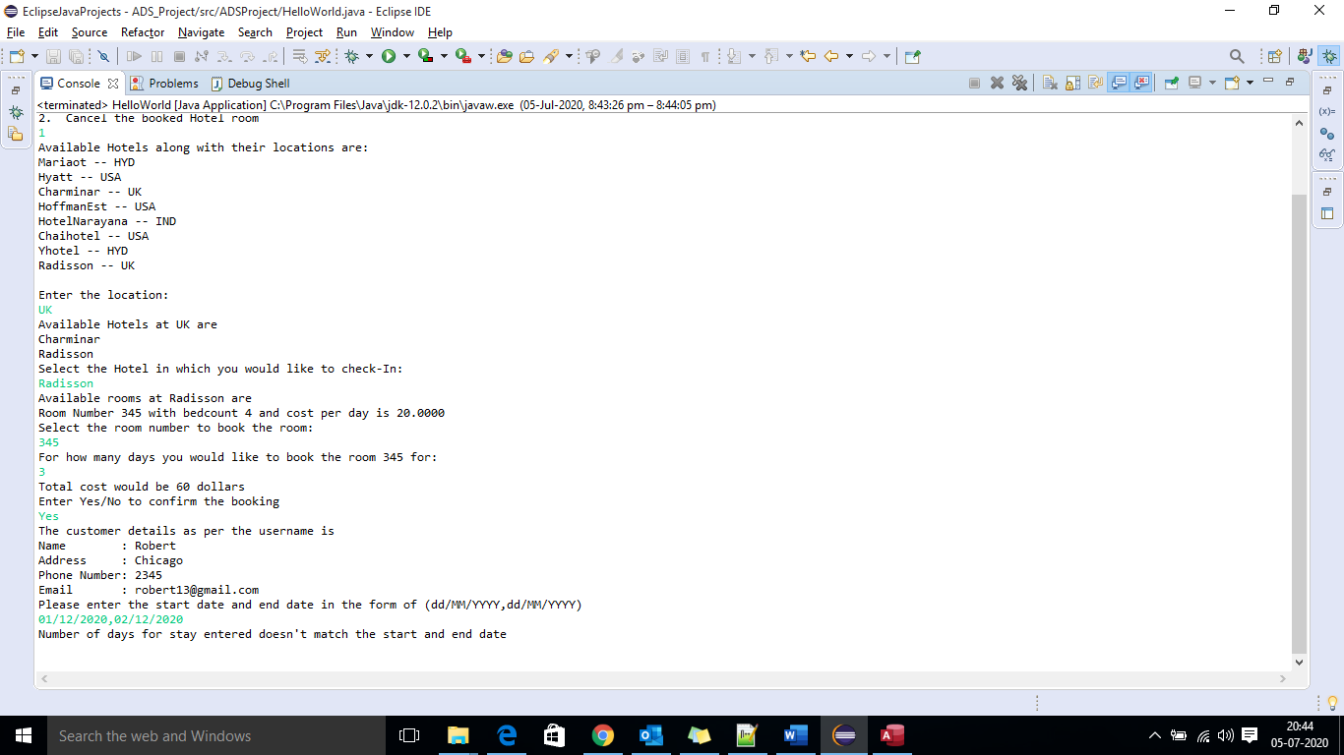

**Discussions:**

Firstly, finalizing the requirements is the essential task since a basic table structure could be only designed if and only if the requirements freeze since we are dealing with SQL tables. The importance of handling NULL values while doing CRUD operations was another major task that could break the applications if not handled properly. While designing the table attributes the importance of the Boolean attributes in determining certain scenarios would rather decrease the writing of complex queries and run time performance improvement of the database transactions.

Based on the basic idea of the project, the design was developed in such a way that every table should hold only independent data i.e. all the tables should be connected via a primary key and foreign key. The same has been implemented, besides since Java is used to make CRUD operations by the service calls, the correct usage of Data structures like HashMap and Hash tables helped to load and store the data lesser as compared to the normal database calls in the project because of fewer calls made to the database the performance of the project increased which is usually measured with the time and space complexity values. While developing the application, I realized that there are many scenarios where and when the database calls throw Exceptions like Null pointer exception. This made me understand the core concept of the Exception handling in Java. The usage of complex queries to retrieve data help me understand the SQL queries well topic like joins and nested queries, besides the date validation task helped to understand various date options and different formats available and could be stored in the database. The limitations of Int, Long Int, Number, the automatic id generator is well understood.

Finally, The future topics might include the expansion of the application with the implementation of Front-end application by adding other scenarios like assistance while booking the Hotel rooms, adding a new role for specific to management services like receptionist role and maintenance service roles like room service, which could enhance the hotel reservation system. Besides, designing the table attributes and dividing it as unique, optional and primary keys gave deep insight knowledge of the database validation scenarios.

**Source Code Attachment:**

 .java source code  .txt source code

 Entire project source code along with the database table values.